GS Server

This is a ASCOM Telescope simulator and SkyWatcher driver. GS Server includes ASCOM telescope driver support and the SkyWatcher Protocol for Synta mounts: EQ8, EQ8R, HDX110, AZ-EQ5GT, Sirius Pro AZ/EQ-G, AZ-EQ6GT, Orion Atlas Pro AZ/EQ-G, EQ6-R PRO, NEQ6, HEQ5, EQ5, EQ4, AzGTi, Star Discovery, CQ350, Fusion-120i, Wave 100i and Wave 150i.



Rob Morgan & Andy Watson

Overview 2
1. Quick Start 2
2. Requirements 3
3. Installation 4
4. Running GSS 5
5. Main Window 6
6. Option Settings 27
7. Log Files 30
8. PPEC 31
9. Flips 32
10. Notes 33
11. Gamepad 34
12. 3D 35
13. Pole Locator 36
14. Pulses 39
15. Plot 42
16. SNAP 44
17. Alignment 45
18. Focus Control 50
19. Mount Types 52
20. SkyWatcher Scripting 54
21. SkyWatcher API 55
22. Learn More 65

Overview
GS Server (GSS) is an ASCOM compliant middleware known as a local server or hub. It’s designed to allow other applications to access your telescope’s mount in a practical and systematic way.
GS Server includes ASCOM telescope driver support using the SkyWatcher Protocol for Synta mounts: EQ8, EQ8R, HDX110, AZ-EQ5GT, Sirius Pro AZ/EQ-G, AZ-EQ6GT, Orion Atlas Pro AZ/EQ-G, EQ6-R PRO, NEQ6, HEQ5, EQ5, EQ4, AzGTi, Star Discovery, CQ350, Fusion-120i. It also comes with a built-in simulator so you can practice sessions without being connected to the mount.

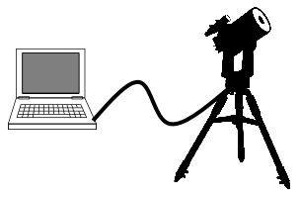
Your mount should already be connected to the computer using the preferred method which is the EQ Direct approach or the USB port for newer models. Specific EQ Direct cable for this approach can be found on the internet. One popular site is http://www.store.shoestringastronomy.com.

Quick Start
- Download and Install GS Server.
- Start your mount and setup a COM port or find which COM port it’s using in windows
- Run GS Server from the desktop shortcut.
- Click the 3 bars to open and configure the settings.
- Be sure to set COM port, Baud Rate, Alignment Type, Mount Type to SkyWatcher, and Observatory Location.
- Click the Close button and exit GS Server
- Open your planetarium program and select an ASCOM connection.
- In the ASCOM chooser select ASCOM.GS.Sky.Telescope and click Ok or Close
- Click Connect from your planetarium program.
- GS Server will start and connect to the mount. If you do not connect check your settings and click the ‘Connect’ button.
- Connect other applications to GS Server as needed.
- If guiding with PHD2 you will want to check mark the option “Reverse Dec output after meridian flip”
- Please restart GS Server if you changed the hemispheres in the Observatory Location.
- WARNING – Ensure all mount cables allow free movement. Alt / Az mounts can track up to 210 degrees Eastwards or Westwards from North. After power loss the mount must be returned to the home position by hand.

Requirements
- Computer with Windows 10 or newer
- Microsoft .NET Framework 4.7.2 installed
- ASCOM Platform 7.0 or later
- Telescope mount that supports the Synta protocol
- USB, serial or SkyWatcher Wi-Fi connection to telescope mount
- EQ Direct cable is preferred if the mount does not have a USB port or Wi-Fi connection

Installation
After downloading Setup .exe file run and follow the prompts. The default location of files and settings can be found in the following locations on Windows systems.
- GSS Program Files- C:\Program Files (x86)\Common Files\ASCOM\GSServer
- Log files – My Documents\GSServer
- Monitor files – My Documents\GSServer
- User Config – C:\Users\{User Name}\AppData\Local\GS_Server
- Notes Templates- C:\Program Files (x86)\Common Files\ASCOM\Telescope\GSServer\NotesTemplates
After installing an update all settings are migrated to the new version. To revert to an older version, run the Setup .exe file for that version. This will uninstall the newer version and GSS will use the previous settings.

Running GSS
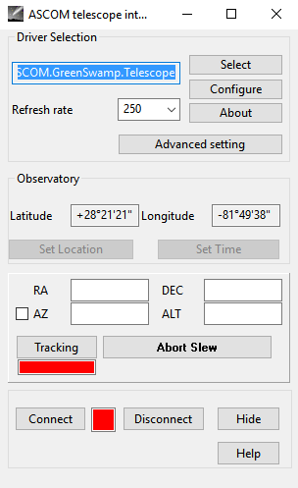
There are two ways to start GS Server; the preferred method is to allow other applications to start GSServer as they connect using the ASCOM interface. Each application that supports ASCOM will have their way to configure and connect. Here is the ASCOM interface from SkyChart (CDC)

Use the Select button to select the ASCOM.GS.Sky.Telescope driver.
If this is the first time connecting to GSServer you will need to configure it before the applications will allow connections. See the configuration section. Once configured, click the connect button. If the configuration is correct GS Server will start within a few seconds. It’s possible the connection may fail. If so, GSServer will start but will not be connected to the mount. Reconfigure the driver and try connecting again.
The second method is to start GSServer.exe file located in the program directory. If starting for the first time configure the driver before hitting the connect button. Refer to the configuration section.

Main Window
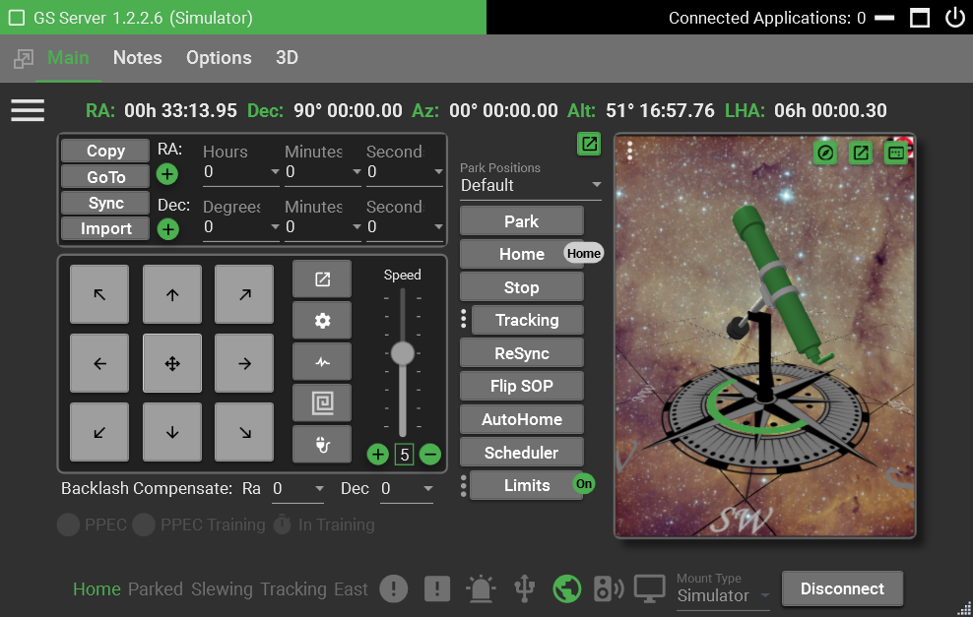
Window Bar
Settings
GoTo
Coords
Hand
Controls
PPEC
Controls
Button Status Bar
Button Controls
Coords
Bar
3D Control
The layout of the main window contains two primary areas: Tabs and Control. Each selected tab will show it’s associated control.
The top of the window shows the version of GS Server, how many connected applications exist, minimize, close buttons and Mount Type.
Connected Applications – shows how many applications are connected To GS Server. If you try to close GS Server when there are existing connections it will prompt you to confirm before closing. GS Server will exit on its own if the last calling application closes its connection.
Mount Type – shows either Simulator or SkyWatcher and is adjusted in the settings.
List of items in the Main Controls
Window Bar
CheckBox – Keeps the window on top of other windows. This is consistent with other GSS windows.
Mount Type – shows either Simulator or SkyWatcher and is adjusted in the settings. The simulator will use your selected highlight color as the background.
Connected Applications – shows how many applications are connected To GS Server. If you try to close GS Server when there are existing connections it will prompt you to confirm before closing. GS Server will exit on its own if the last calling application closes its connection.
Coordinates Bar
RA (Right Ascension) – the distance of a point east of the First Point of Aries, measured along the celestial equator and expressed in hours, minutes, and seconds. Double click on the value to swap between hours and degrees display.
Dec (Declination) – the angular distance of a point north or south of the celestial equator.
Azimuth – the direction of a celestial object from the observer, expressed as the angular distance from the north or south point of the horizon to the point at which a vertical circle passing through the object intersects the horizon.
Altitude – the distance measurement, usually in the vertical or "up" direction, between a reference datum and a point or object.
Local Hour Angle (LHA) – it is the angle between the meridian of the observer and the meridian of the object you are pointing at. This can be used to tell how far the object is before or after the meridian. Double click on the value to swap between Local Hour Angle and Local Sidereal Time. Local Sidereal Time equals the Right Ascension (R.A.) of the celestial coordinate of an object that is currently crossing the local meridian.
GoTo Control
Supports RA Dec and Az Alt GoTo. Right click in the GoTo Control to swap between coordinate systems.
Copy Button – Copies the current mount coordinates into the dropdown boxes.
GoTo Button – Tells the mount to move to the position defined in the dropdown boxes.
Sync Button – Takes the position entered and reset the mount to that location (Ra Dec only). Any syncs larger than 45 degrees in either direction from the current position will not be accepted.
Import Button – Select a .fit file to open and copies the RA and Dec from the .fit file into the dropdown boxes. This could be used as a manual plate solve where a plate solver validated the pointing location then you can load those coordinates from the image file.
Backlash Compensate
Used when guiding to account for slack within the axis gearing. If you are using the PHD backlash Compensate then there is no need to adjust this setting, leave the settings at 0. Review the video “Dec Backlash Adjustment” for help.
PPEC Control
This control is enabled or disabled depending on the capabilities of each individual mount. Clicking the Mount info button in the status bar will show if PPEC is supported for the mount.
PPEC (Permanent Periodical Error Correction) - Checkbox to turn on or off PPEC. The grayed-out timer will turn green when training is in progress. For more information see the PPEC section of this document.
PPEC Train – Checkbox to start the training process for PPEC
Buttons Controls
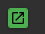 - Opens a separate window
Park Positions – List of available positions for parking. The default is two listings ‘Default’ and ‘Home’. Home is same position as the Home button. Default is a copy of the park position from previous versions of GS. If you never set the previous version park position, then Default will be set to the home position. Any applications requesting GS to park the mount uses the selected position at the time of the request. Adding and removing positions is done in the settings area of the Main tab. Park positions are defined and stored separately for equatorial, polar and Alt/Az mounts.
Park Button – move the mount to the defined park position defined within the setup settings. If mount is current slewing the button will stop the mount. Click again and the mount will park to the position in the dropdown.
Home Button– moves the mount to the initial home position which is typically counterweight down and the dec axis pointing to the pole. For Alt/Az mounts the home position is defined as Az pointing to North and the telescope tube horizontal. For polar mounts the home position is defined as Az pointing South (North for the southern hemisphere) and the telescope tube 5 degrees above horizontal. If the mount is currently slewing the button will stop the mount. Click again and the mount will move home.
Stop Button– Stops mount movement
Tracking Button – turn on or off the selected tracking rate to use. Will be automatically applied after a slew or goto. For Alt/Az mounts tracking will maintain a constant Right Ascension and Declination so that an object of interest remains in the center of the field of view. However, without a field de-rotator the field of view will appear to rotate about the center point. This rotation may be acceptable for visual observation or shorter exposure imaging but star trails will be visible on longer exposure imaging.
ReSync– Resets the mount axes encoder positions to either the home position or a preset park position. The home position for equatorial mounts is defined as Dec is pointing to the pole and Ra with the counterweights down. For polar mounts the home position is defined as Az pointing South (North for the southern hemisphere) and the telescope tube 5 degrees above horizontal. For Alt/Az mounts the home position is defined as Az pointing to North and the telescope tube horizontal.
When resyncing with a park position make sure the mount is turned on, connected, and in the desired park position. If not in the correct position, manually move the mount to the desired position and ReSync with that park position. For encoder accuracy be sure the manual position is as close to the park position as possible.
Flip SOP Button – for equatorial mounts moves the mount to the opposite side of the pier if allowed by hardware limits. Works in both directions. The button text is color accented when flip is allowed. An “On” badge is active when a flip is in progress.
For Alt/Az mounts moves the mount in the opposite direction to positions around the South azimuth direction pier if allowed by hardware limits. Works in both directions. WARNING: The mount will slew 360 degrees through North to reach the new position. Check that cables will not twist or bind.
For polar mounts moves the mount to the alternative RA/Dec position if allowed by hardware limits.
AutoHome Button – If your mount is equipped with auto home sensors then this button will assist in recovering the mount when it starts in a position that is not recognized as a park or home position. This would be helpful if the mount loses power and is then powered on and the axis positions are unknown. AutoHome will attempt to find each axis home sensor. It does this by moving each axis 5 degrees at a time towards the sensor for a maximum of 100 degrees. If it did not find the home sensor it will tell you at the end of the process. Once finished you will have the option to run it again for another 100 degrees search. If you’re using a side saddle you can enter an offset that will move the mount +90 or –90 degrees after home is found and AutoHome is complete.
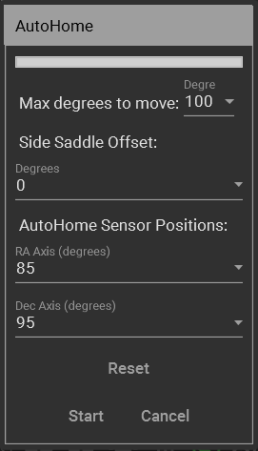
For German equatorial mounts only: Your mount's AutoHome sensor may not be exactly at the 90° position due to manufacturing tolerances, which are typically a few degrees. The GEM AutoHome position is GEM counterweight down pointing to the celestial pole. This is the (90, 90) Ra/Dec position which you can check using the RaDec graphic. To compensate for small errors in the auto home sensor position:
- Click the Auto Home button
- In the "Sensor Position Adjustment" section:
  - Enter the actual Ra axis position where your home sensor is located
  - Enter the actual Dec axis position where your home sensor is located
- Click Start to commence the AutoHome function
To determine your AutoHome sensor position:
- Run auto home with default settings (90, 90)
- Note where the mount actually homes to
- If it's off by a few degrees, adjust the settings by that amount
- Example: Mount homes to (87, 91) instead of (90, 90)
  - Set Ra Sensor Position to 87.0 and Dec Sensor Position to 91.0
Click "Reset" to set the assumed the AutoHome sensor position to (90, 90) – counterweight down pointing to the celestial pole
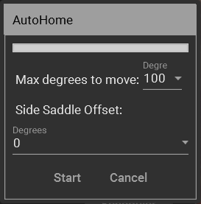
For polar mounts only: If the auto home sensors have been moved from the default position these values must be set from the Settings page before starting AutoHome. The default value for both axes is 90 degrees (GEM counterweight down pointing to the celestial pole), and these values must only be changed if your mount has modified auto home sensor positions (e.g. EQ8 dual telescope polar mounts).
WARNING - If you slew greater than +180deg from home and loose power, when doing the auto home, instead of slewing in a negative direction to get back it will slew in a Positive direction and possibly twist or bind existing cables. It’s recommended to monitor the mount at all times while doing an AutoHome.
Scheduler Button – Allows a park to be scheduled at a future date and time. When checked it uses the currently selected Park Position, and the button will display “On” until the event is completed. It’s the user responsibility to ensure no other software is interfering or working the mount at the time the event is scheduled to run. This option is reset when GS server restarts.
Limits Button – Enables or disables tracking and horizon limits. The “On” badge is displayed when limits are active. Click the three dots to display the Set Mount Limits dialog (described below under Settings)
Hand Controller
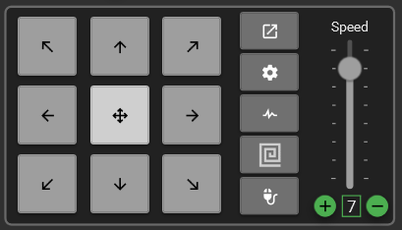
Speed – 8 settings to control the speed of the hand controller buttons. All speeds are relative to the Max Slew Rate in settings.
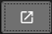 Opens a separate or new window for the hand controller. You could open this then minimize the GSS application so you have more screen room for other applications
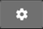 Open the hand controller options dialog
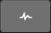 Open the pulse parameter dialog
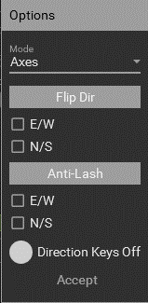
Mode - Axes - Follow clockwise and counterclockwise directions of the axis. User would be able to set a flip switch for N vs S Hemi directions. Axis1 would be Ra/Az and Axis2 would be Dec/Alt
North (CW Axis2), South (CCW Axis2)
East (CW Axis1), West (CCW Axis1)
Mode - Guiding - Follow guiding directions in the same way guiding programs calibrate NESW with pulses for guiding. The following is defined by the ASCOM standard and would always apply. The user could not flip directions.
North (+ declination/altitude), South (- declination/altitude)
East (+ right ascension/azimuth). West (- right ascension/azimuth)
Mode - Pulse Enables pulse movement mode. The arrow keys operate in pulse mode. The pulse duration, interval between pulses and rate are user configurable.
Flip Dir – reverses the direction that the mount moves, swapping East and West / North and South
Anti-Lash – attempts to compensate for mechanical backlash errors in the mount when using the hand controls. Use the checkboxes to turn off/on the compensation for each axis. Best used at slower speeds when trying to use the hand controls to keep an object aligned.
E/W – Works when tracking is on and is based on the amount in the Backlash RA setting. If there is backlash in the RA axis each move east will move the lash to the wrong side. This will move the mount proportionally back to the west trying to remove the backlash so tracking will re-engage without having to travel the backlash distance.
N/S – Works when reversing the N/S direction and is based on the amount in the Backlash Dec setting. When the reverse direction is applied the compensation is applied before the actual move. This takes up the backlash in Dec before the reverse move is applied. Each reverse direction the backlash will be proportionally applied.
Direction Keys Off – If ticked direction keys are temporarily disabled whilst the mount is slewing. Otherwise, if clear, pressing a direction key whilst the mount is slewing cancels the slew.
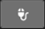 Mouse lock. When you engage the lock you can then pick up the mouse and move to the mount where you can control certain movements. Left click this button and the mouse will lock and not allow movement of the cursor. A popup message will appear as a reminder it’s on. At the same time it enables the mouse buttons for the mount controls below. It’s recommended to have a 3 to 5 button mouse with a wheel.
- Press any keyboard key to stop or return the mouse cursor.
- Left or Right click for Dec or RA movements
- Center wheel to increase or decrease speed.
- Center wheel click to switch between RA or Dec control
- X1 button for Spiral Search “Out” command
- X2 button for Spiral Search “In” command.
 Spiral Search.
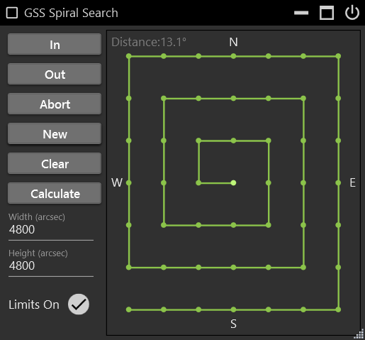
The spiral contains dark points or dots that represent each GoTo coordinates. If no points exist then the next button movement ‘Out’ or clicking ‘New’ will create them. Right click on any point and a GoTo dialog will appear.

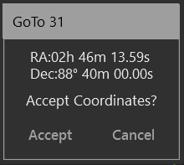
In – Executes a GoTo to the next inward point. Once at the center the button will do nothing. Available as a gamepad command.
Out – Executes a GoTo to the next outward point. Once at the end the button will do nothing. If no points exist they will be created on the first outward move. Available as a gamepad command.
Abort – Stops any GoTo movement but keeps tracking on. Available as a gamepad command.
New – Creates a new set of points or GoTo coordinates for the spiral. Available as a gamepad command.
Clear – Removes the points from the spiral
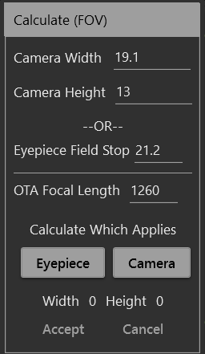
Calculate – Opens the dialog to calculate the needed width and height settings
All settings are entered in millimeters (mm). If searching with a camera enter the camera width and height along with the OTA focal length then click the Camera button. When using an eyepiece enter the field stop and OTA focal length and click the Eyepiece button. When the width and height are populated select accept to copy these values to the spiral window.
The search strategy is to create an invisible search box using the Width and Height as the field of view (FOV) size. Each point created on the spiral represents is a single FOV.
Width – The FOV width in seconds of arc
Height – The FOV height in seconds of arc
Use the Calculate button to assist in setting theses.
Limits On – When ‘On’ or check marked two limits will be imposed; 1) Meridian flips will not occur, so an ‘Out’ movement would do nothing if it required a flip. 2) Distance is a defined as the area around the spiral. Anytime the mount moves beyond that area the spiral will reset and no points will be defined. The distance is displayed at the top of the spiral and is the angular distance from the center of the spiral to its farthest point plus another 40%. Anywhere within this area you are free to move the mount how you want and the spiral will not reset.
Tips – As you move closer to the poles and away from the celestial equator the RA or Width movements will overlap exponentially. If you want Dec to overlap set the seconds of arc to a slightly smaller number.

How to calculate FOV in arc seconds
http://astronomy.tools/calculators/field_of_view/
The Field of View Calculator at Astronomy tools is probably one of the better online tools. For imaging mode simply enter the equipment information and calculate the Field of View. Take the smaller of the 2 numbers in degrees and multiply it by 3600. i.e. 2.01° x 1.37°1.37 degrees x 3600 = 4932 arc seconds. Enter 4932 into the Spiral Search Arc Seconds.
An alternative to the online tool for a sensor is it to do the calculation manually. To do this, use the smaller side of the chip. (Width of chip in mm * 3460) / (focal length of optic train in mm) = arc minutes * 60 = arc seconds. i.e. 13mm * 3460 / 545mm = 82.5 arc minutes = 4951 arc seconds.
Another alternative for sensors is to take the smaller pixel size divide by focal length then multiply by 206.3 to get arc seconds per pixel. Multiply that by the amount of pixels on the smaller side of the chip. At binning 1 use the following formula. i.e. 4.63um / 545mm * 206.3 = 1.75 arc seconds per pixel * 2822mm = 4945.8 arc seconds
For eyepieces use visual mode on the field of view calculator. Enter the equipment, take the field of view and multiple by 3600. 1.1°* 3600 = 3960 arc seconds. The manual formula is Scope Focal Length / Eyepiece Focal Length = Magnification. Eyepiece FOV in degrees / Magnification = real Field of view in degrees. Multiply that by 3600 for the arc seconds. i.e. 545mm / 10mm = 54.5 mag. 60deg / 54.5mag = 1.10091 * 3600 = 3963 arc seconds
Graphic Section
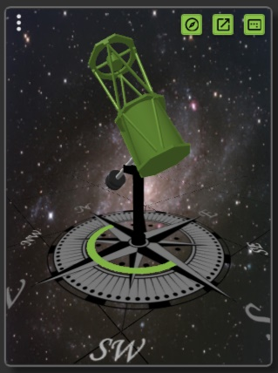
The 3 dots allow you to select one of the graphic modes for viewing; None, AltAz, RaDec, or 3D. The 3D model shows a German equatorial, polar or alt/az mount and telescope dependent upon the user selected alignment mode.
Warning – Some computers may not be able to display or render the 3D model correctly due to hardware or system limitations. Please check under the Options tab for the Render Capabilities number. Anything less than 2 maybe have these issues so use one of the alternative modes.
- Opens a separate or new window.
- Resets the position of the 3D to its default
- Saves the current 3D model position and view
3D Mode – There is also a Tab item in Options to turn on/off a separate 3D model control. Within the settings on the 3D tab you can select which 3D model to use. Right mouse click on the model to use the following shortcuts…
- Pan - Shift W, A, S, D or Shift Arrow keys or Mouse wheel click and hold.
- Pitch, Yaw - Right mouse click and hold and move
- Zoom – Shift Page Up, Page Down or Mouse wheel
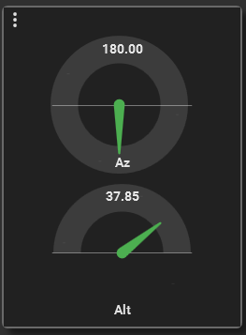
Alt shows the elevation and will switch sides depending on E/W orientation. Az points north at 90 degrees and 180 degrees for southern hemisphere.

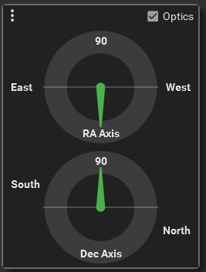
Ra/Dec: The Optics checkbox will flip the RA axis 180 degrees. View the RA axis as either the counterweight pointing down or the upward direction of the axis to the sky.

Bottom Status Bar – shows when the mount is in the Home or Parked position.
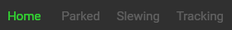 Status Lights – Parked, Home, Slewing, and Tracking are highlighted when active. If tracking is active and one of the axes has been commanded to move at a user specified rate the tracking status will pulse.
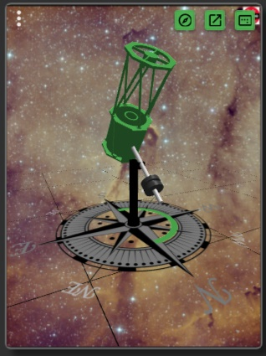
East / West – For German equatorial mounts East (pier East) where the mechanical Dec is in the range -90 deg to +90 deg. Beyond the pole West (pier West) where the mechanical Dec is in the range -180 deg to -90 deg or +90 deg to +180 deg
AzEast / AzWest – For AltAz mounts AzEast when motion is Eastwards from North and AzWest when motion is Westwards from North.
Normal / ThroughPole – For Polar mounts Normal where the mechanical Dec less than 90 degrees and ThroughPole where the mechanical Dec is greater than 90 degrees.
The indicator ring on the compass base of the 3D model shows the current state of the mount relative to the pier.
 Errors Alert – Will turn red if an error is logged. This can be reset by clicking on it.
 Warnings Alert – Will turn yellow if a warning is logged. This can be reset by clicking on it. Warnings can be caused by a variety of reasons from serial connections to the driver being asked for non-valid information. Check the session log for specific warning messages.
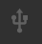 Connection – Is lit green when the mount is connected with a serial or Wi-Fi connection. Click for additional mount information.
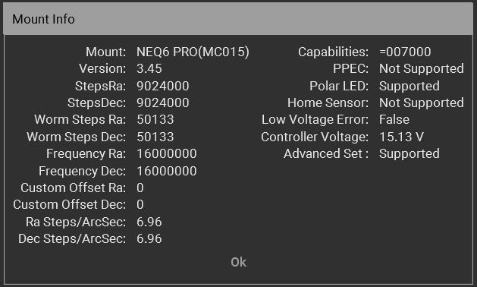
Dependent upon the mount controller card firmware capabilities and version the values for some fields may not be available.
 Monitor – Status of the internal Monitor. Will be lit green when active. See the Settings Control for more information about the Monitor.
    Tracking Rate – one of the 4 icons will be displayed representing the selected tracking rate. Sidereal, Lunar, Solar, or King.
 Axis Limits – is yellow when one or more of the axes reaches a limit such as passing too far past the meridian for a polar mount or setting the elevation too high or too low for an Alt Az mount. Warning – Axis limits will not stop the mount from moving and simply displays a warning light. It is up to the user to see that the mount is not damaged. Click the icon and you will be presented with a few options.
- Nothing – The mount will take no specific action
- Turn off Tracking – Tracking will stop
- Park – Mount will slew to the set park position.
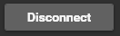 Mount connection button. When connected Disconnect will be displayed. When disconnected Connect will be displayed. When connecting any errors will be logged and shown in a popup window.
Sky Watcher Settings
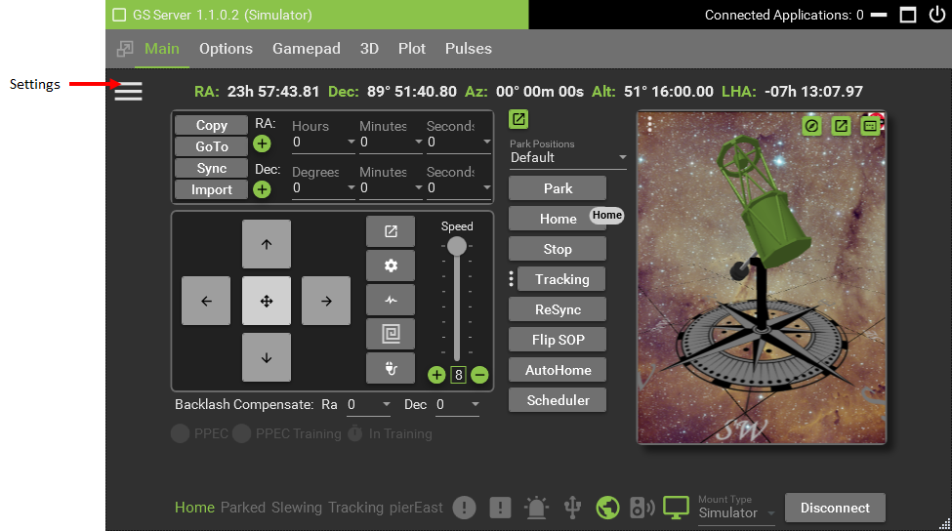
Click the 3 bars to open the settings for the Main Control.
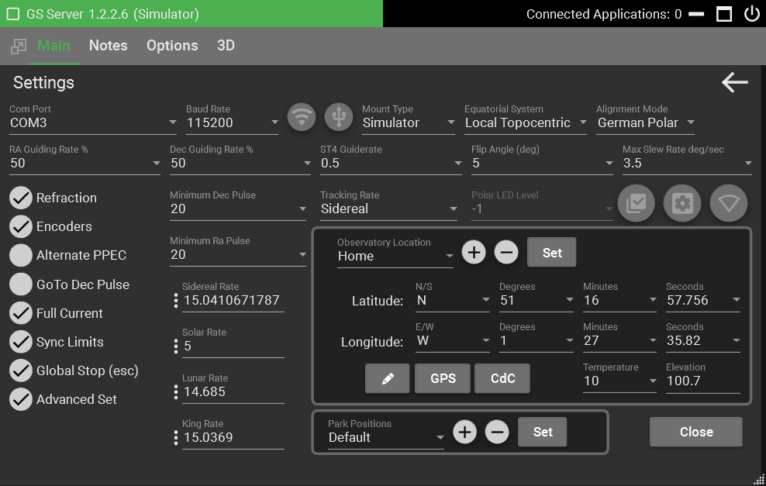
Com Port – Lists available or active ports. It is up to the user to select the correct port for the mount. If you don’t know the mount port open or search for Device Manager and look in the ‘Ports (COM & LPT)’ section of the Device Manager.
Baud Rate – Rates from 300 to 230400 are available. Most mounts work at the default 9600 rate, USB at 19200.
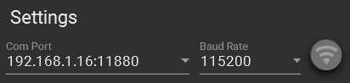

Wi-Fi – Select the Wi-Fi method for connecting to the mount. A Wi-Fi enabled mount or SkyWatcher compatible Wi-Fi dongle is required. The Com Port list will auto populate with available Wi-Fi addresses.

USB – Select the USB method for connecting to the mount. The Com Port list will auto populate with available COM ports.
Mount Type – Choose between SkyWatcher (physical mount) and Simulator. The simulator will work in all alignment modes (Alt/Az, Polar and German Polar). The selected mount type will be used when an application attempts to connect to the server.
Equatorial System – Local or TopoCentric is the default but. TopoCentric is also known as JNOW. Other is set to apparent. The server will accept input and output to the display the coordinates selected.
Alignment Mode – German Polar is the default. Polar (fork) and Alt Az options are also available. The telescope must not be connected when changing the alignment mode. If necessary, reset the telescope position before (re)connecting. See Mount Types section for an overview of the different types.
Rates – Sidereal, Solar, Lunar, and King are present from the ASCOM standards. Clicking the 3 dots will confirm a reset to the default setting.
Max Slew Rate – speeds for the hand controller are a percent of the max rate. If you want slower movements change this to a smaller number.
Minimum Dec Pulse & Minimum Ra Pulse – Warning, it’s recommended you leave this set to 20 and only change after discussing issues and options on the support forum. This option is to refine guiding to a very small step increment. A correct setting is based on baud rate, guide rate, type of mount and settings in your guiding software. 20 milliseconds is the default and will work in almost all cases. A lower setting could cause poor performance depending on the capabilities of individual mounts.
Guide Rates – A percentage of the selected rates to use for guiding. The default 50% is a good starting point for guiding with applications like PHD2. Pulse guiding is not enabled for Alt/Az mounts.
Over Meridian Limit – degrees before or passed the meridian the mount can travel before running into a limit alert. Warning – limits will not stop the mount from moving and simply displays a warning light. It is up to the user to see that the mount is not damaged or is flipped when necessary.
Refraction – Adds the effects of light as it passes through the atmosphere to the coordinates.
Encoders – Turns on and off the internal mount encoders.
Alternating PPEC – This allows pulses from guiding software to not be truncated or cut when the mount implements PPEC. When the internal PPEC runs it’s been shown that some pulses may be randomly cut short because of the timing in PPEC changes. This problem doesn’t seem to exist for mounts using the ST4 or handbox interfaces only using an EQDir cable and the internal PPEC. The ST4 and Handbox interfaces implement a PPEC on/off strategy when dealing with pulses. This means that PPEC is turn off then the pulse is executed, then PPEC is turned back on. This strategy keeps PPEC from interfering with the pulses. Using this option emulates that on/off strategy. Any mount using the internal PPEC and an EQDir cable should consider turning this option on and evaluate its long-term affects. If not using the internal PPEC then there is there is no need to use this option.
Full Current – When you turn on the mount, by default the mount will track at half the watts/amperage. The full current option tells the mount not to track at half current and to use the full current. Full current is recommended unless you’re running off a battery and power consumption needs to be at a minimum.
GoTo Dec Pulse – A new alternative method when tracking and guiding. This turns pulses from guiding commands into a Dec GoTo command. It will slew like a normal GoTo which is different than the default pulse, which is based on the guide rate. GoTo slews are quicker and accurate. You can turn this on at any time even when guiding or tracking. If this option is turned off then guiding in Dec follow the normal guide rate and percentage. It’s recommended to use this option and evaluate it over the long term.
Sync Limits – When checked it enforces the mount cannot sync to targets that are greater than 30 degrees from the current position. It’s recommended to leave this checked as a safety precaution. Warning – When not checked the mount could sync to an object that is too far from its current pointing position throwing off the real axis positions to a point where the axis may end up colliding with the pier or something unintended.
Global Stop (esc) – Allows the escape key to stop the mount at any time. When check it works when the GSS window is minimized or is behind other windows. Be aware that global keys may also be hooked into to other programs that you may be running. Be sure to check if hitting the escape key will also affect them.
Advanced Set – Enables Skywatcher mount advanced control commands. These are more efficient and provide additional information. The mount capabilities are checked and, if advanced commands are not available this setting is ignored.
Park Positions – Click the + and – buttons to Add or remove park positions. Use the Set button to assign the current mount axes positions to the selected park position. You cannot edit or modify the name of an existing position, but you can reset its positions using the Set button. If you need to change a name it’s best to create a new park position and then remove the old one.
Observatory Location - Latitude and Longitude of your observatory is used to calculate local positions. Click the + and – buttons to Add or Remove observatory locations. Use the Set button to assign the currently displayed latitude and longitude to the selected observatory location. You cannot edit or modify the name of an existing observatory location, but you can reset its latitude and longitude using the Set button.
GPS – Reads a COM port for available NEMA sentences. Select GGA or RMC. GGA is the default and RMC does not contain elevation data. GS will retrieve the first found tag GNGGA, GPGGA, GNRMC, GPRMC. Hit retrieve again for another tag search. The time is also pulled for and compared against the local pc clock. Any discrepancies are displayed. If you ran GSS as Administrator you will see a checkbox to update the system time. Check your Windows system options for items that may change the time again like Internet Time Services. For viewing, guiding, and imaging a few seconds off isn’t going to matter.

External Capabilities – Settings that tell external applications the capabilities of the driver.
Can Set Park – When checked this allows external applications to set the telescope Park position to the current telescope position. The default is checked.
Track After Unpark – When checked the telescope will start tracking immediately after unparking. Uncheck if this action is not required, for example when the mount might collide with a closed roll-on roll-off observatory roof. The default is checked.

Custom Gearing – If you have to replace any gears on your mount or changed the ratio then this will allow you to enter that information. Enter the total steps for Ra and Dec along with the total teeth count for each worm gear. The total steps divided by the total worm steps will give you the total worm teeth count. Only integers are allowed so only round down if the total worm steps are a fraction. Leave the tracking offset at zero until a drift test is done to determine if any offset is needed. The offsets numbers relate to a small percentage of Sidereal to apply along with the tracking rates when tracking. Also, the offset will only be applied if tracking is below 2x normal sidereal speed.
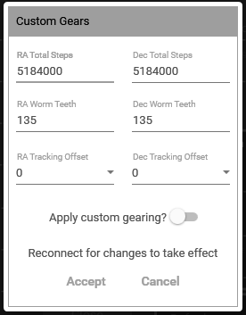
To use the custom gearing be sure to turn on the “Apply custom gearing” toggle button. Use the Connect/Disconnect button as all changes require a new connection to the mount. When the custom gearing is being applied the gear icon color will change to the selected accent color.
WARNING: Only enter the custom information if different gearing was put in the mount. Using the default gearing from SkyWatcher does not require the custom information. Entering invalid information can result unexpected results and possible harm to the mount. If you do not know what gearing is in the mount please use one of the support links at the end of this manual.
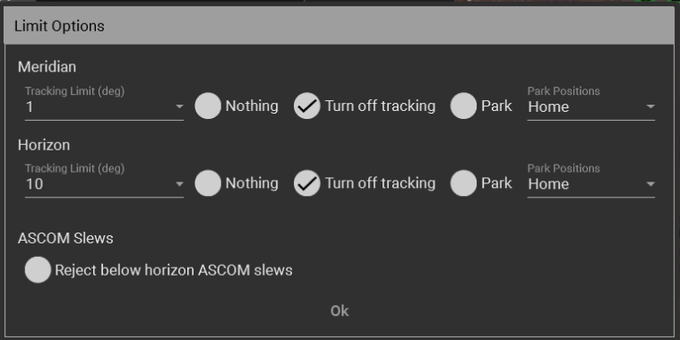

Set Mount Limits – German Equatorial
When a German equatorial mount continues tracking past the meridian the telescope will be below the counterweight and the telescope may collide with the pier.
The Limit Options dialog sets the action taken when the mount tracks past the meridian or below the horizon. The tracking limit, in degrees sets point when action can be taken. The available actions are
- Do nothing: the mount will continue moving. Only select this option if the mount position is being monitored independently and action will be taken to prevent damage
- Turn off tracking: the mount will stop tracking and remain at its current position
- Park: the mount will slew to the selected park position and stop all motion
The ASCOM Slews option enables automatic rejection of slew and go to actions (RA Dec and Alt Az) from external clients that would move the mount to an unsafe position below the horizon limit. This limit does not apply to user-initiated slewing from the Go To panel.
Set Mount Hardware Limits - Polar
Limits can be set for polar mounts to prevent excessive motion in either axis which may cause damage to cables. The setting dialog graphics show the mount axis movement limits.
The right ascension limit is symmetric about the home position – South in the Northern hemisphere and North in the Southern hemisphere. The angle of the canted polar pier determines the lower limit. The angle of cant is latitude dependent and this is automatically added on to the value of the lower limit. The upper limit is usually set to 90 degrees to allow the mount to be horizontal when pointing North.
The dual telescope can be oriented with the primary telescope on the East or the West side of the dual saddle. The usual position orientation is primary telescope on the East. Click the change button to swap the side. GSS must be restarted after changing the dual telescope side. For the Southern hemisphere the default side is West.
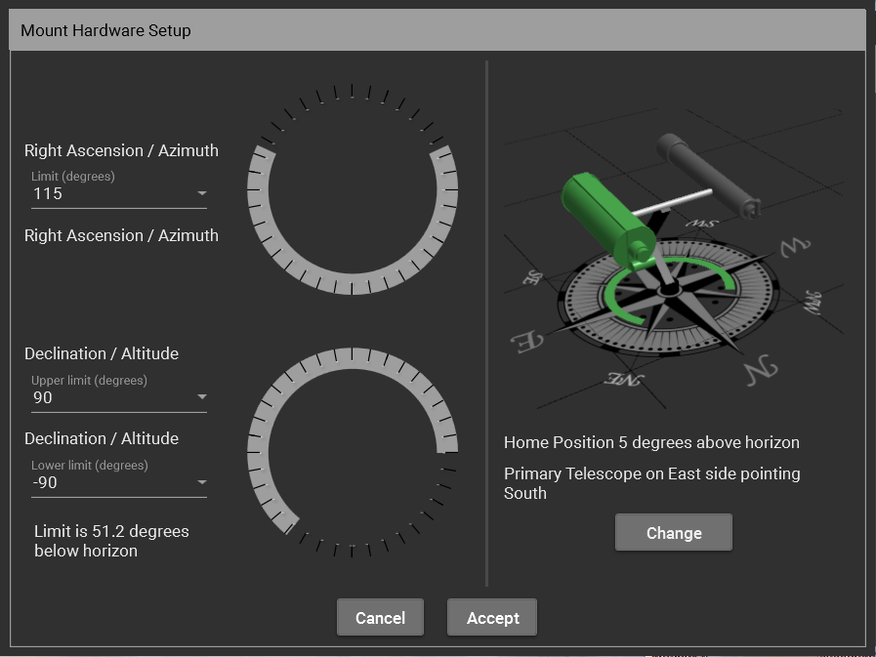
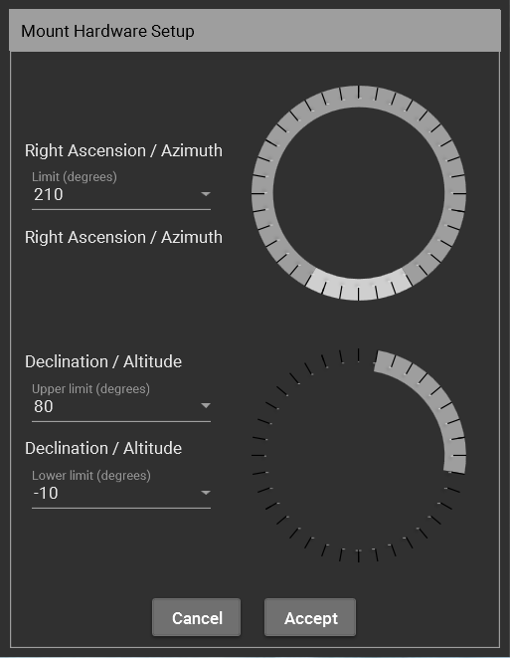
Set Mount Hardware Limits – Alt Az
Limits can be set for Alt Az mounts to prevent cable wrap around the azimuth axis and to prevent altitude axis collisions when close to the zenith. The setting dialog graphics show the mount axis movement limits.
The azimuth limit is symmetrical about the zero degrees position, i.e. North. The positions that can be reached by slewing either clockwise or counterclockwise are highlighted on the graphic
The altitude limit can be set to allow below the horizon motion. SkyWatcher Alt Az mounts typically have an upper limit of 75 degrees for the altitude axis.

Set Home Positions (Polar Mounts Only)
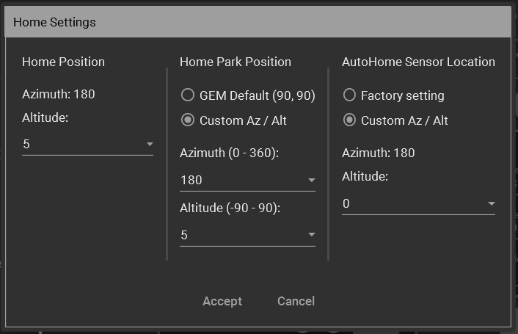
The home position, home park position and AutoHome sensor location can all be independently defined for Polar Mounts.
The home position is the mount position used by the “Home” button. It is specified using azimuth and altitude.
The azimuth is fixed at 180 degrees for observatory latitudes in the Northen Hemisphere and at 0 degrees for the Southern Hemisphere. The altitude can be set to any value between -30 degrees (i.e. below the horizon) and +30 degrees (i.e. above the horizon).
The home park position is the mount position used by the “Park” button when the “Home” park position is selected. It can be set to the GEM default position (RA = 90, Dec=90) equivalent to a counterweight down, celestial pole pointing configuration. The primary telescope is above the secondary. Alternatively, the home park position can be defined using Azimuth and Altitude coordinates. This option will only accept normal mount positions. Through pole positions are rejected.
Use the park positions dialog on the “Settings” page to manage park positions using RA and Dec position values.
The AutoHome function uses the AutoHome sensor to return the mount to a defined position. After this position has been reached the AutoHome function resets the axis values to the location of AutoHome sensor. Skywatcher AutoHome capable mounts such as the EQ8 series, are set to a “factory” default (RA, Dec) location equal to (90, 90), i.e. telescope pointing to the celestial pole with counterweight down.
The physical location of the AutoHome sensor can be changed for each axis. This requires a mount hardware adjustment, typically carried out for dual saddle mounts. The location can be at the default factory setting or a custom setting.
The AutoHome sensor location is specified using azimuth and altitude (c.f. home position). The azimuth is fixed at 180 degrees for observatory latitudes in the Northen Hemisphere and at 0 degrees for the Southern Hemisphere.
The altitude can be set to any value between -30 degrees (i.e. below the horizon) and +30 degrees (i.e. above the horizon).

Options

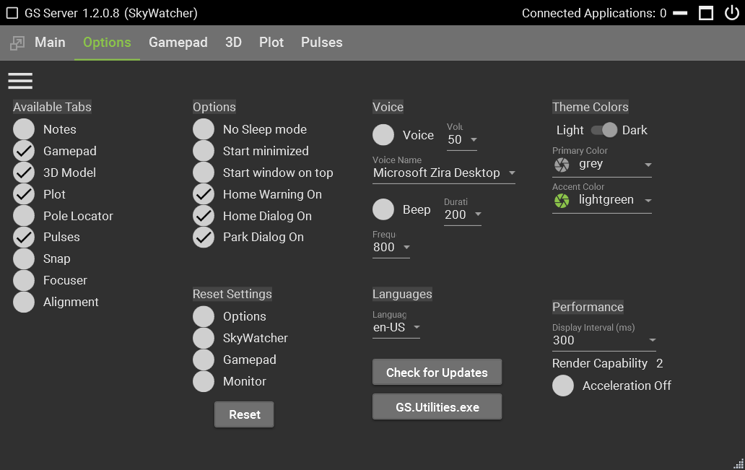
Available Tabs – Turns off or on selected tabs at top of the window. You cannot turn off the Options tab it will always be available. It’s recommended to set what tabs you want before connected to any hardware. If you have a gamepad the tab must be turned on to activate.
No Sleep mode – When GS Server is running it will move the mouse a few pixels every 45 seconds to keep the windows screen saver from starting. This may also help to keep USB ports from going into sleep mode.
Start Minimized – When GS Server is started it will show only in the windows taskbar in a minimized state. Click the GS Server icon in the taskbar to open the window to normal state.
Start Window On Top - When GS Server is started the window will be forced to show and stay on top of all other windows.
Home Warning On – When checked a popup warning will show that asks the user to put the mount in the home position. Uncheck this to stop showing the warning.
Home Dialog On – When checked a popup dialog will show that asks to the user confirm the command to go to the home position. Uncheck this to stop showing the confirmation dialog.
Park Dialog On – When checked a popup dialog will show that asks to the user confirm the command to go to a park position. Uncheck this to stop showing the confirmation dialog.
Voice/Speech on – Turns on/off the selected Microsoft synthesized voice. Windows loaded voices will be shown in the selection box. Refer to Microsoft for loading or unload voices into Windows operating systems.
Theme Colors – Choose light or dark themes along with the Primary and Accent colors.
Performance – This controls how often the driver polls the mount for position information. The faster the polling the more CPU utilization is needed. Unless there is a specific issue it’s recommended to leave at the default 300.
Render Capability – This shows the capabilities as defined from Microsoft of your graphics card. This is important for the 3D model. If this number shows below 2 you may have problems showing the 3D graphics.
Acceleration Off – Turns of the graphics card acceleration.
Reset Settings – Rests the selected settings back to their default settings. Each checkbox goes to a set of option and matches the menu items. i.e. if you select SkyWatcher and click reset it will set all the settings under the Main menu back to their default settings. The default setting will take effect the next time GS server is started. It’s recommended after you reset any setting to restart GS server.
Language – Sets the culture. If interested in creating a specific Language file. There are 3 English versions is available in the C:\Program Files (x86)\Common Files\ASCOM\Telescope\GSServer\LanguageFiles; GSServer_en-US.xaml, GSChart_en-US.xaml, and GSUtil_en-US.xaml. Each file goes to the corresponding .exe file in the install folder. These files can be edited with any language, rename the filenames with the correct culture name and submit to the groups.io site to be included in a future release.
Check for Updates – Looks up over the internet for the latest release version. Shows the current or local version and the latest version available for download. When the Download button is clicked a browser window will open and it will attempt to download the latest version.

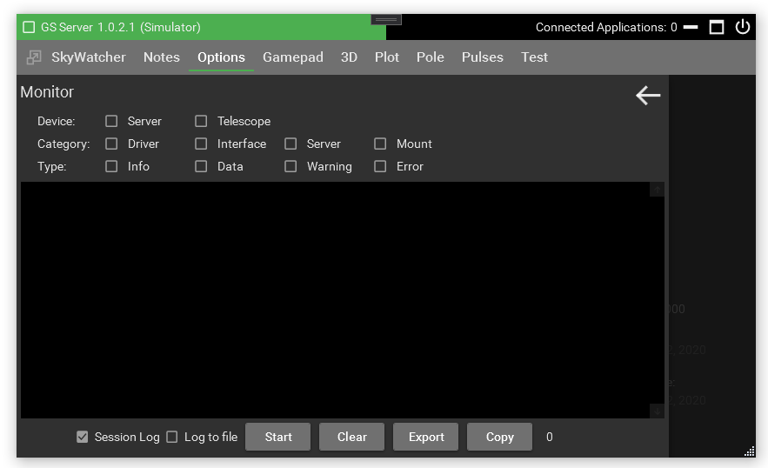
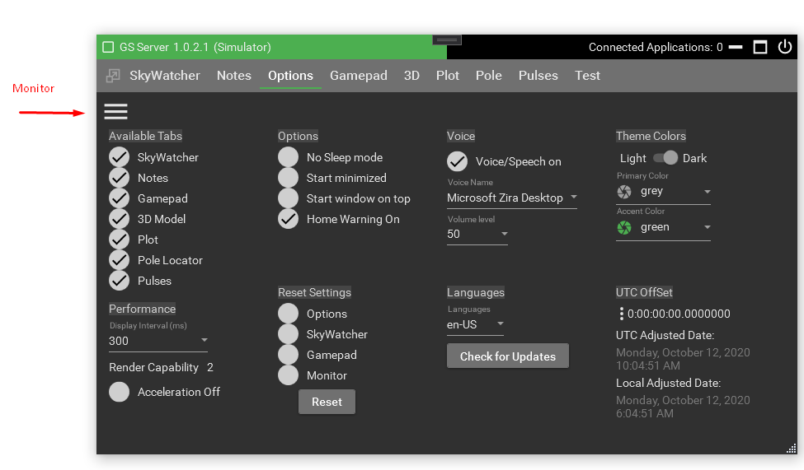

Monitor – The Monitor shows real-time logging by Device, Category, and Type. The Telescope selection refers to any control that is a type of Telescope like SkyWatcher. Category of Driver is for any incoming operations directly to the ASCOM driver. Interface would be the User Interface commands such as the hand controller items. Category Server would be the internal workings of GS Server. When the monitor is started it will not quit until turned off, even is the GS server is exited and started again. All files logged are kept in My Documents/GSServer.
Session Log – When checked turns on the log and keeps the last 5 rolling sessions logs.
Log to File – When checked anything shown in the monitor will output to a log file.

Log Files

Log files are in “My Documents\GSServer”. There are 4 types of logs: Session, Error, Pulses, and Monitor. Any logs older than 7 days are automatically removed when GS starts. Session, Error, and Pulses are started by default while Monitor is created manually using the Monitor screen. All log entries are created by the Monitor so they are also available using the Monitor screen.
Session log – Shows user actions taken along with any warnings issued by GS. Format: GSSessionLogyyyy-dd-MM-HH.txt {record Number}, {yyyy:dd:MM:HH:mm:ss.fff}, {Device}, {Category}, {Type}, {Thread}, {Method}, {Message}
Error log – All errors issued by GS. Format: GSErrorLogyyyy-dd-MM-HH.txt {record Number}, {yyyy:dd:MM:HH:mm:ss.fff}, {Device}, {Category}, {Type}, {Thread}, {Method}, {Message}
Monitor log – Items created from the Monitor screen. Format: GSMonitorLogyyyy-dd-MM-HH.txt {record Number}, {yyyy:dd:MM:HH:mm:ss.fff}, {Device}, {Category}, {Type}, {Thread}, {Method}, {Message}
Pulses log – Items created from the Pulses screen. Format: GSPulsesLogyyyy-dd-MM}.txt

PPEC
Permanent Periodic Error Correction (PPEC) allows the mount to correct the right ascension (RA) for manufacturing errors in the worm wheel. PPEC Training your mount will take small movement corrections and store them within the mount. These corrections are then played back as the RA moves when PPEC is turned on.
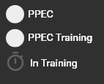
How to PPEC train your mount - Before starting a training session your mount should be able to track and guide at a stable rate. When you are happy with the way in which the mount is guiding and you thinks its stable and consistent, start a guiding session near the meridian and let it stabilize. Start the PPEC training session by clicking the PPEC Train checkbox. When the mount starts collecting data the timer icon will turn green. The mount will continue to collect data for several minutes. When finished the timer will turn gray and the PPEC Train checkbox is unchecked. You can now start and stop the PPEC replay using the PPEC checkbox. It’s recommended that you use PPEC for any future tracking or guiding sessions. If you’re guiding session worsens turn off PPEC and validate your guiding is back to normal. You can retrain the mount at any time as long as tracking is turned on.
PPEC on/off checkbox – Turn on or off playback of corrections
PPEC Training Checkbox – Used to start a new collection session
PPEC Data collection icon – Indicates mount is collecting error correction data
Note: When using PHD2 for guiding it’s recommended to turn off PPEC during the PHD2 calibration process and turn it back when finished.

Flips
The “Flip Angle” setting is the number of degrees, before and after the meridian where everything in-between is known as a flip zone. When the limit is reached certain actions can be taken on the main menu under Axis Limits such as Do Nothing, Stop Tracking, Park, or how log to track after reaching the flip angle. Each degree equates to about 4 minutes of sidereal tracking time. The default setting is 20 degrees, so this means the flip zone is 40 degrees total, 20 before the meridian and 20 degrees after the meridian.
Applications like NINA or SGP can take advantage of flip zone by forcing the flip using the “Side of Pier” command before or after hitting the meridian. It’s recommended that the flips occur well before hitting the Flip Angle setting. This way the limits can be used as a safety factor and an action can be taken if the flip failed from the image acquisition application. Applications like Voyager use the “Destination Side of Pier” to determine when a flip can occur. Basically it asks GSS if a GoTo was executed what side of pier the mount would end up on. Based on this Voyager would test the targets coordinates to see if a flip can occur. To properly accommodate applications that use a GoTo, set the Flip Angle to either a setting of 0 or 1 and the Axis Limits to “Do Nothing”. Then tell the application to wait a number of minutes, typically 1-5 minutes after passing the meridian to test for the flip. If the flip fails then the “Tracking Limit” will be hit and the action selected will be taken.
The “Flip Angle” also affects GoTos and slews. Any target within the flip zone can be pointed at by either side of the pier, that’s the purpose of the zone. To determine which side of pier takes action depends on what side is closest. i.e. Say you’re pointing east and about 45 degrees in altitude and you want a target that is 5 minutes passed meridian. Since the target is in the flip zone and the mount is in the pier west configuration the slew will not flip the mount because the axis is closer on the current side. If the target was passed the flip zone then an automatic flip would occur since that’s the only pointing state that will work.
Additional help videos that explain how flips work, “How to Flips” and “Flip Angle Gotos” are on the website greenswamp.org/.

Notes
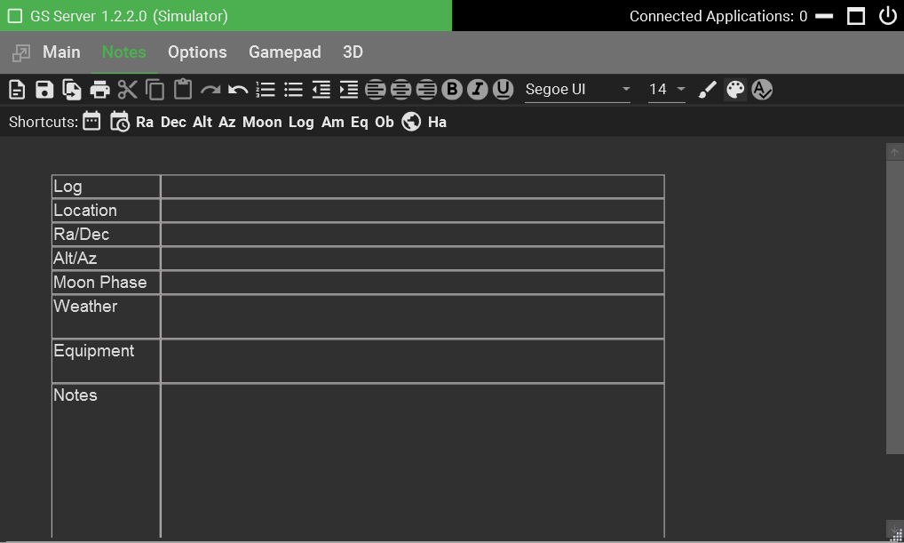
Notes works with files that use the Rich Text Format (.rtf). Other programs that also support rtf are Microsoft Word and WordPad along with Dropbox, OneDrive, and Google Drive.
Notes can be used to store information or logs during your viewing sessions. Various templates can be created using MS Word or WordPad then loaded into Notes. A sample template was installed into the application directory. See the Installing section for locations.
Shortcuts Bar – contains number of buttons that will insert information where your cursor is located on a form or in the window.

Gamepad
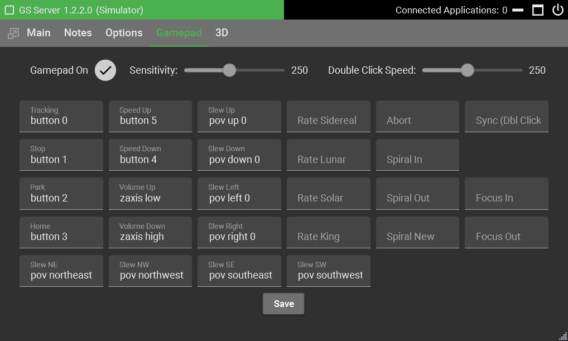

When configuring a gamepad or joystick it’s recommend you not be connected to a mount.
Turn on the Gamepad and click the mouse in the box where you want to select the gamepad control. Click save to try out the new settings. After you connect to the mount you can judge how the sensitivity should be set. A faster setting will repeat buttons that are held down too long.

3D
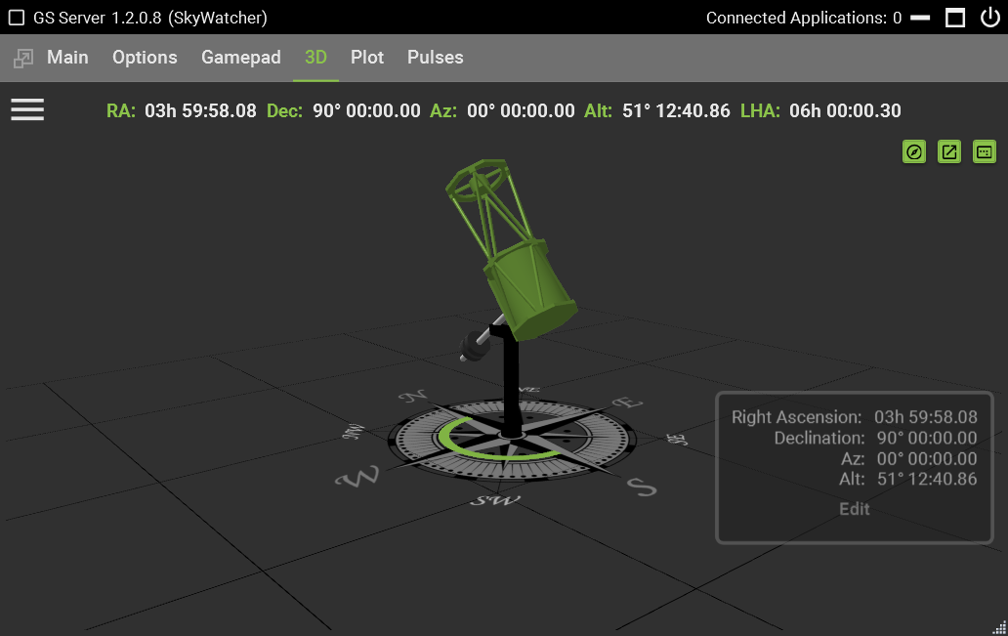
With the 3D tab you can watch a model of the mount as it moves in real time. The position of the mount is dependent on the proper starting of the mount and GS being in the home position or a parked position. If the mount starts up in an unknown position this view may not be correct.
Use the mouse right click & hold to pan or the mouse wheel to zoom the model for different viewing perspectives.
Save View button – saves the current position and view of the 3d model
Open Window button – opens a new window so that you can organize your desktop and still see the 3d models.
Reset View button – reset the model back to the default viewing perspective.
Edit button – click to choose which information fields are displayed in the view.
3 bars – Under the settings you can select the 3d model type to view.

Pole Locator
If you don’t have access to hardware like Polemaster or camera for plate solving then using the polar scope maybe your only option. Use can use the Pole Locator tab to polar align the mount using a polar scope. If you’re in the north hemisphere use the directions for Polaris. In the southern hemisphere use the location of Sigma Octans as an indication of location.

Polaris Polar Scope Alignment in 6 Easy Steps

Prerequisites - Verify Observatory information. If not correct adjust in the Main/Settings tab.
Step 1: Align and level the mount - Align the mount roughly towards Polaris, don’t want to move it afterwards. Level it and get as close as you see fit. It does not need to be perfect but as close as possible is good enough. Bring Polaris anywhere inside the viewport using the Alt and AZ knobs on your mount.
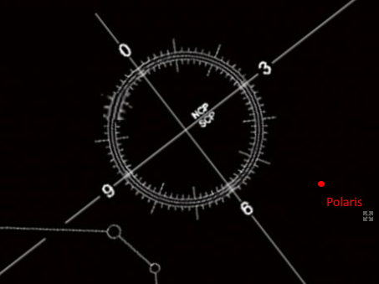
Step 2: Center Polaris in the Crosshairs - Tip: carefully rotate the RA axis and make sure Polaris doesn’t stray as the circle moves around. Polar scope should be aligned properly.
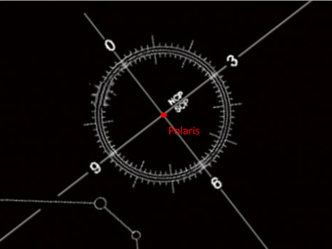
Step 3: Move Polaris off to the side and outside the circle – manually use ONLY either Altitude or Azimuth knobs to move Polaris outside the circle. Do this to align the polar circle perfectly horizontal in the next step. Move it approximately double the distance from the center of the circle. It’s important that you only touch one set of polar alignment knobs, not both!
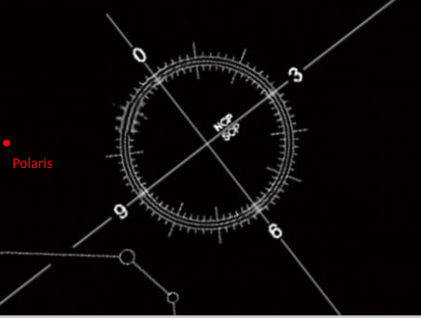
Step 4: Align the RA axis and the polar scope - rotate the right ascension axis until one of the lines is on Polaris.
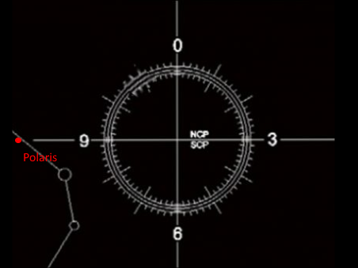
Step 5: Use the Locator in GS to find the correct position for Polaris (red dot). The dash circle line represents position for 2020 and the inside circle is 2028.
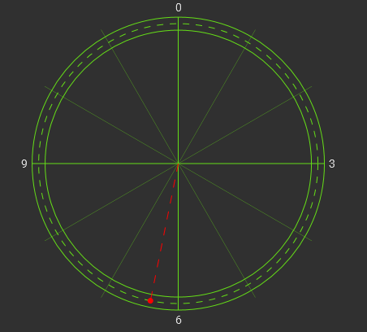
Step 6: Adjust the Alt and AZ knobs on your mount to move Polaris to the exact position
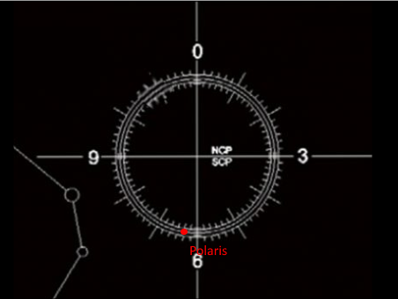
Complete, to refine the polar alignment consider doing a drift alignment.

Pulses
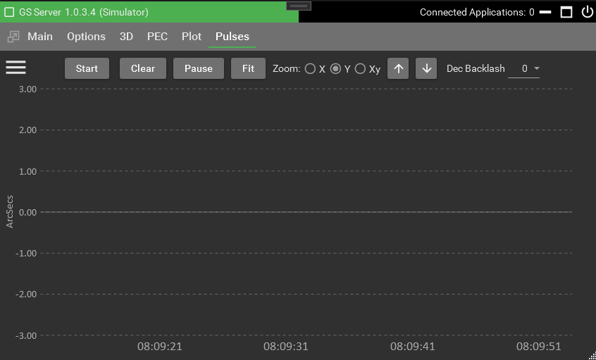
Pulses are captured from guiding applications like PHD2 which will send the guiding corrections to the driver in the form of individual pulses. These pulses can be captured and displayed here to see the performance of guiding for the mount.
GS ChartViewer – ChartViewer is another program packaged with GS that allow external viewing of the Pulses Logs. This allows logs to be viewed by others that have the ChartViewer program. Locate GS.ChartViewer.exe in the install directory.
Start – Starts and stops the chart. Pulse logs are automatically saved to the documents area.
Clear – Removes any drawings on the screen only
Pause – Stops the timeline from auto scrolling and allows the chart to be panned and zoomed.
Fit – Readjusts the chart to fit the screen using the selected scale.
Zoom – Changes the mouse and arrow behaviors. Use the mouse wheel or arrow key buttons.
Dec Backlash – Allows adjusting the Dec backlash while watching guiding live. Refer to the section Backlash Compensate.
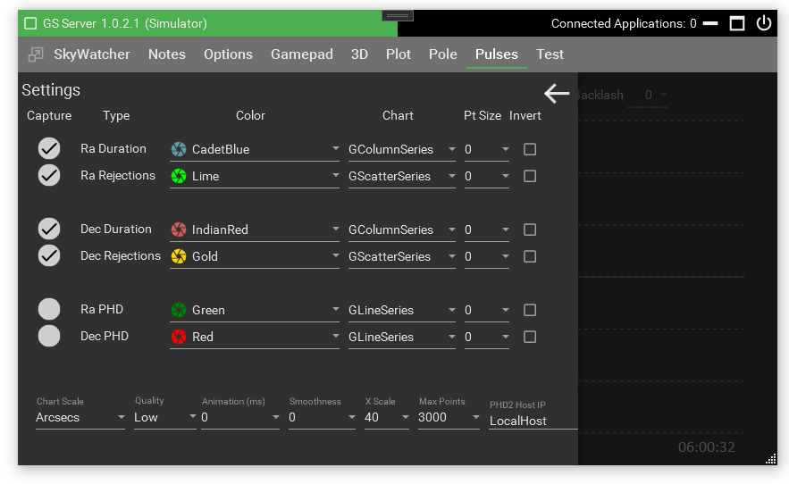

Capture – Check to show and log a series.

Type
- Ra Duration – Normal Ra corrections being process by the driver
- Ra Rejections – Rejected Ra pulses
- Dec Duration - Normal Dec corrections being process by the driver
- Dec Rejections - Rejected Dec pulses
- RA PHD and Dec PHD – Displays the guiding performance from PHD2. If one is checked a connection will be made to the PHD2 server so make sure it’s turned on in the PHD2 settings. The PHD Host IP is also required for the connection to work.
Rejected pulses are pulses that are not accepted to process by the driver and are typically too small. The rejection size is determined by the minimum pulse setting in the SkyWatcher tab. Specific minimum settings are mount specific but typically 20 milliseconds is a good generic setting. If lots of pulses are being rejected you might have to adjust the guiding application or adjust the minimum pulse setting.
Chart – Selects a specific series to show such as Line, Column, Step Line, or Scatter.
Point Size – Some series can show specific points on the chart and this would determine the size.
Invert – Will invert the data so basically it will flip the data from above zero to below zero or visa-versa.
Scale – Scale will determine the Y scaling to be used for all captured items.
Quality – Determines how much detail to show when zoomed out or in. If set to low the farther you zoom out the less detail is shown. The more you zoom in more detail will be shown. Low is the best setting for performance and a higher quality will slow down zooming effects.
Animation – Each series can animate how points are drawn on the screen. Use this in conjunction with smoothness for different effects. Any setting above 0 will affect performance of the chart.
XScale – How many seconds to show on the timeline
Max Point – How many points to keep in the series while the chart is being shown on the screen. Larger settings can affect performance of the chart. This can be useful if you pause the chart and scroll back to view the history.
PHD2 Host IP – IP or host name of the PHD server. This is required if capture is turned on for PHD items. Localhost is the default computer.

Plot
The Plot tab will chart the axes real time.
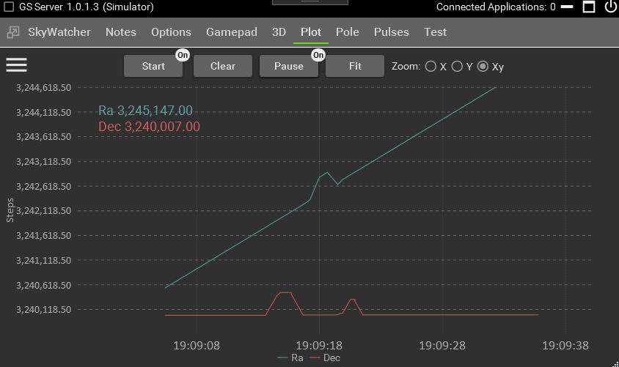
Start – clears the plots and starts a new chart based on the settings.
Clear – removes the current plots from the screen.
Pause – stops the plots from moving forward in time. This allows you to use the mouse to move the chart around.
Fit – Attempts to readjust the plot to fit in the current chart’s Y axis. Using this in conjunction with the zoom options.
Zoom – Changes the mouse and arrow behaviors. Use the mouse wheel or arrow key buttons.
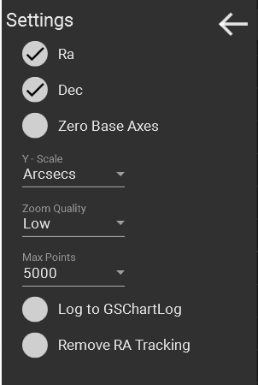
Settings – Click the three lines to show the Plot Settings
Zero Base Axes – uses zero as the axes starting point rather than the home positions which are typically set at 90/90 degrees.
Y Scale – Display plots in micro steps, arc seconds, or degrees
Zoom Quality – the father zoomed out the less detail is shown. When adjusted higher, more detailed is shown at zoomed out distances. Default is set to Low so you need to zoom in to improve the details. Low is best used for performance reasons.
Max Points – Set the maximum number of displayed points
Log to GSChartLog – Log plot data to file for later display and analysis
Remove RA Tracking – Adjust plot data to remove RA tracking (e.g. sidereal) to show raw mount movement

SNAP
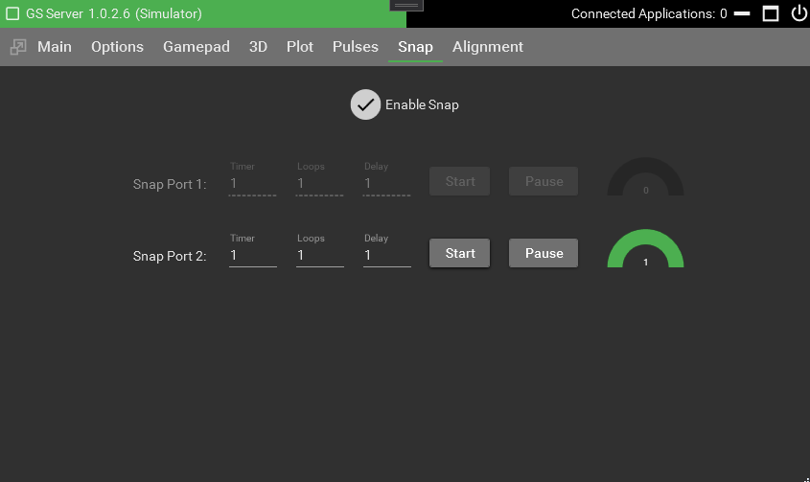
If your mount has a one or two SNAP ports you can use this tab to trigger each. Once you click ‘Enable Snap’ one or two ports will be available depending on the capabilities of the mount.
Timer – The amount of time in seconds length to trigger the port.
Loops – The number of times to trigger the port.
Delay – The amount of time in between each loop.
Pause – Pauses at the beginning of the next loop until the pause is turned off.
Start – Begins the looping actions
Start On – Cancels the current actions
4 external commands are available to use from NINA. Numbers ending in 1 will be to Start and numbers ending in 0 are for Stop
Syntax order is ABC
A = command to trigger snap and is not a zero :O
B = Snap port number 1 or 2 depending on mount
C = false/off = 0 , true/on = 1
Commands for Snap1
:O10
:O11
Commands for Snap2
:O20
:O21
Examples:
To start Snap1 send :O11
To stop Snap1 send :O10

Alignment
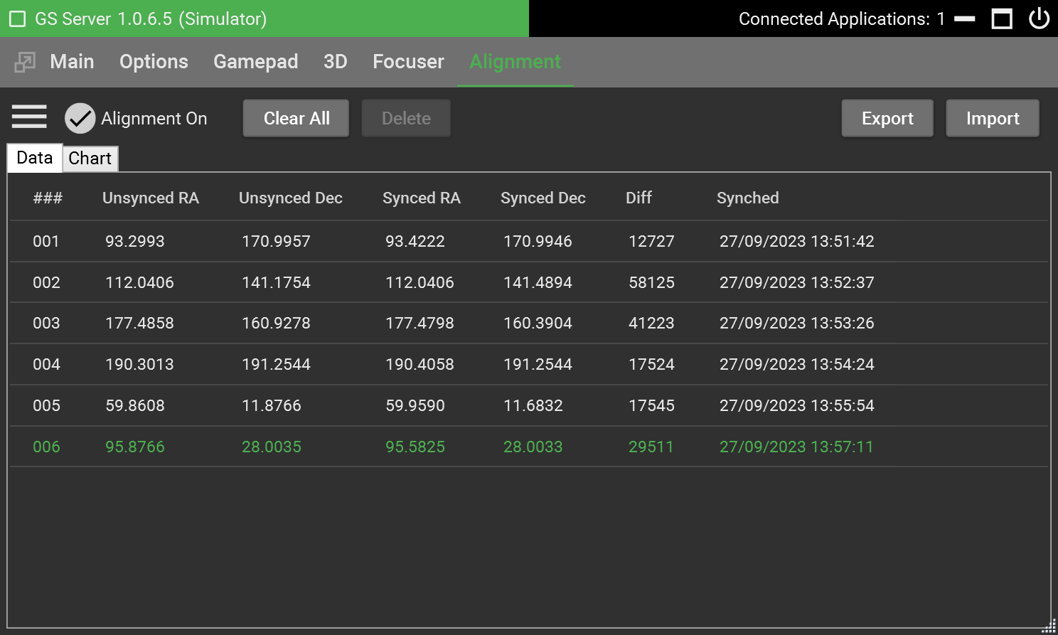
The Alignment tab can be used to improve pointing accuracy by building up a model of points in the sky along with the necessary RA/Dec corrections at each position. Models are created by aligning with known stars and syncing. Typically, a planetarium program is used to slew to a known star. The star is then observed to ensure that it is centered in the eyepiece. If it is not, the position of the telescope is adjusted using either the telescope controls in the planetarium program or the control buttons in GSS. Once the star is centered a “sync” command is issued either in the planetarium program or using the Sync button on the Main tab of GSS. The sync command will add an alignment point to the model along with the adjustments made in RA and Dec.
When alignment is switched on GSS will determine what positional correction will be required at the target position. The exact method used to calculate the correction depends on the choices made in the Alignment options (covered later in this section).
The controls available on the Alignment tab are explained below.
Alignment On – Put a check in this check box to switch alignment on.
Clear All – Clears the current model deleting all alignment points.
Delete – Deletes the selected alignment points.
Export – This button allows the user to save the current alignment model to a file.
Import – Use the Import button to import a previously exported alignment model.
Chart Tab – The chart tab shows a pictorial representation of the current alignment model.
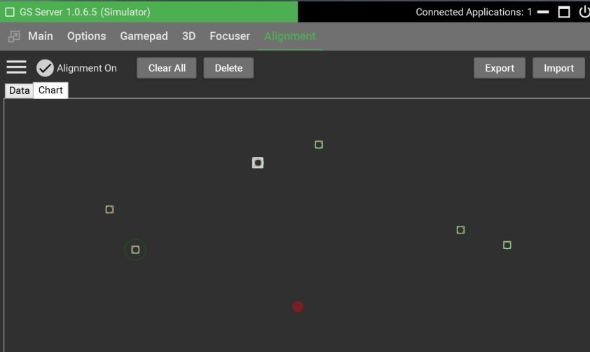
Each alignment point is represented by a green square and a red circle representing the corrected and original positions of the telescope at the time of each Sync command.
The larger green circle (as shown around the lower left alignment point above) indicates that only this one alignment point has been used to calculate the alignment correction at the current telescope position. The current telescope position is indicated by the filled red-circle.
If three or more alignment points are available for the current telescope position red and green triangles are shown to indicate the points used.
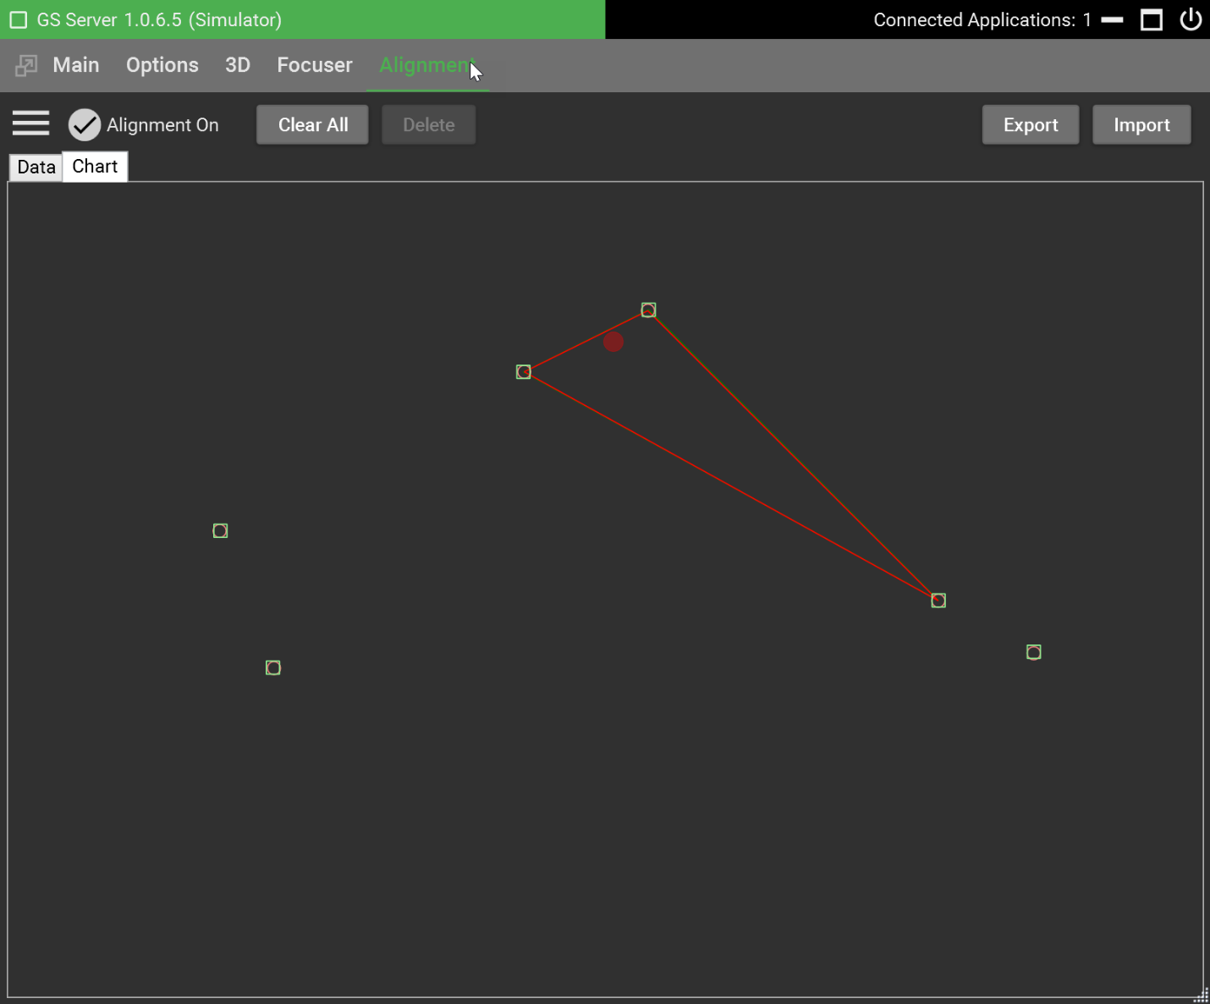
The options available for controlling how the alignment corrections are determined are shown below and can be accessed by clicking the options button in the top left corner of the Alignment tab.
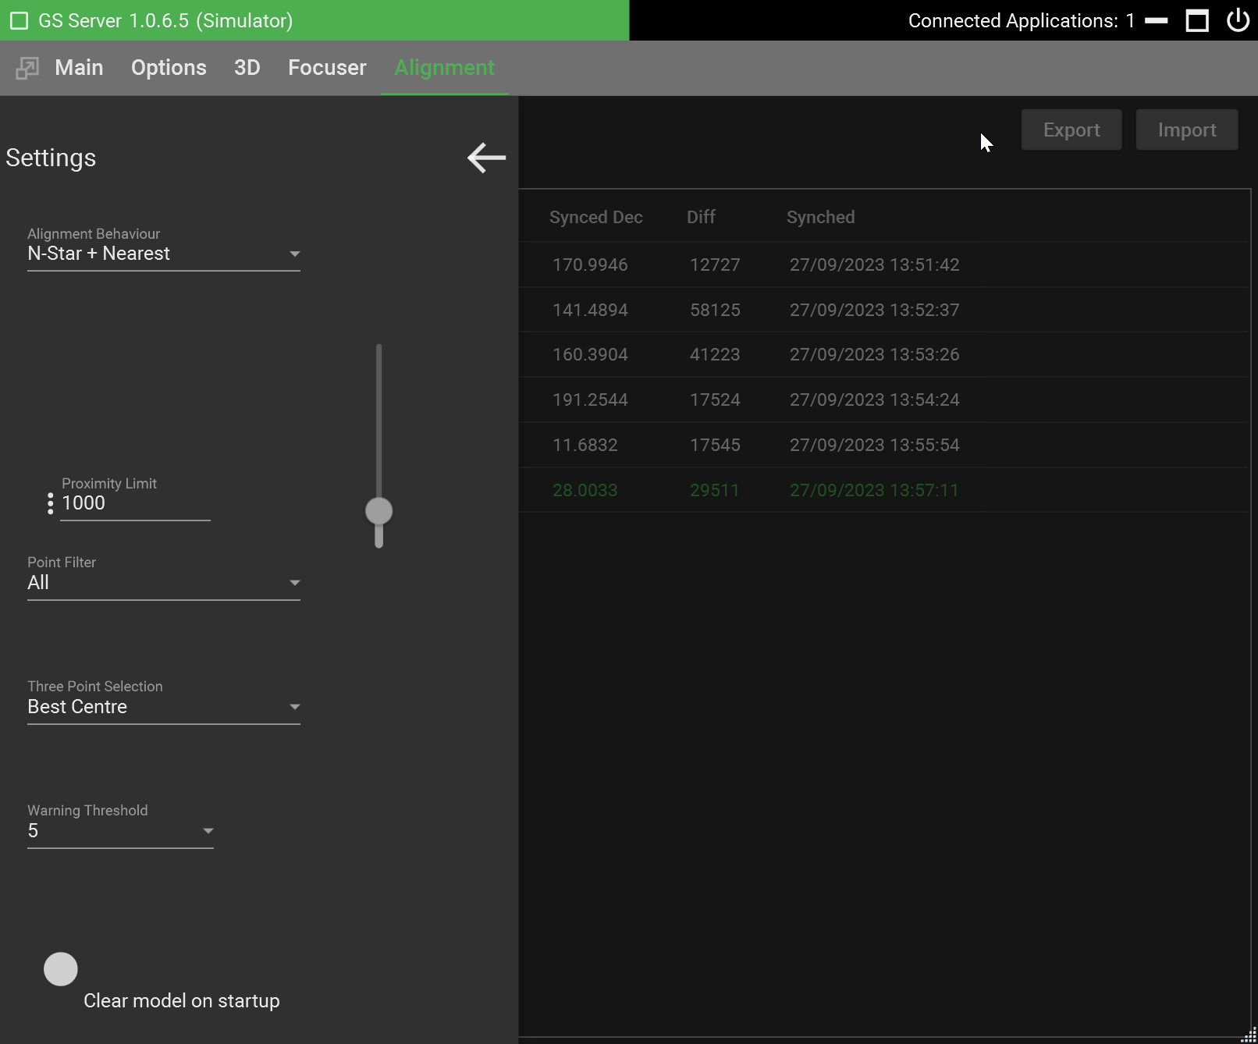
Alignment Behavior – The options available here are:
N-Star + Nearest – GSS attempts to find 3 stars to determine the alignment correction (subject to the other settings below). If it fails to find 3 stars it takes the nearest alignment point to the target position.
Nearest – Takes the nearest alignment point to the target.
Proximity Limit – This number represents arcseconds and is the distance used to determine if a newly synched alignment point should replace an existing alignment point or add to the model.
Point Filter – The point filter allows you to control which alignment points will be included in the three-point (N-Star) selection process. You can choose from:
All – All points are considered,
Pierside Only – Only points on the same pier side as the target position are considered; or,
Local Quadrant - Only points in the same quadrant as the target position are considered
Three Point Selection – This option determines how GSS will choose the 3 alignment points used in the calculation. The options are:
Best Center – Take the 3 points forming an enclosing triangle with its center nearest the target telescope position, or
Closest Point – Take the 3 points that are closest to the target telescope position whether or not they form an enclosing triangle.
Warning Threshold – If GSS determines that an unusually large correction is required (compared to the corrections you entered when building up the model) it will display an alert and switch off alignment. This is to protect your mount from possible damage. The warning threshold allows you to control the sensitivity of this check. For example, a value of 5 means that GSS will NOT display an alert unless it calculates a correction more than 5x the maximum correction entered via a Sync when building the model.
Clear model on startup – Put a check in this check box if you do NOT have a permanent setup and you need to build a new point model every time you switch on your mount.

Focus Control

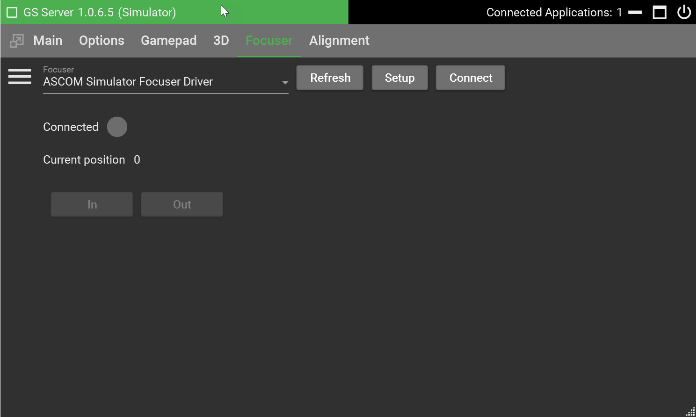
The Focuser Tab in GSS allows you to connect to an ASCOM focuser. Once connected, Gamepad buttons can be configured to move your focuser in and out. The tab presents the following controls:
Focuser drop-down list – Choose the ASCOM focuser applicable to you.
Refresh – Refreshes the list of ASCOM focusers available.
Setup – Opens the ASCOM Setup dialogue box for the chosen focuser.
Connect – Connects to the chosen ASCOM focuser. The button will change to “Disconnect” when an ASCOM focuser has been connected.
In – Moves the focuser in one step.
Out – Moves the focuser out one step.
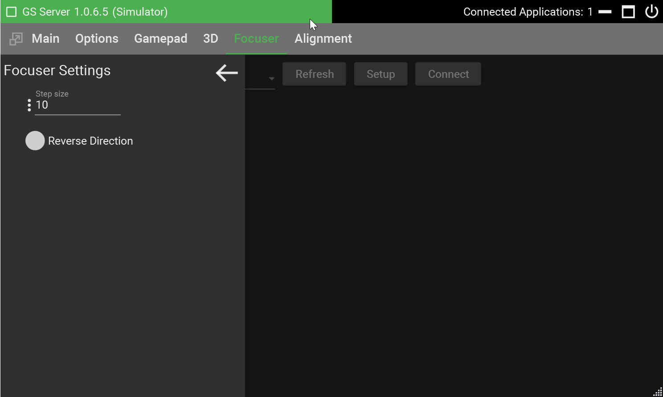
There are two focuser options accessible via the options button in the top left corner of the Focuser tab.
Step size – Specifies the number of steps the focuser will be on each In or Out button press.
Reverse Direction – This tick box allows you to correct the focuser direction if you find that it goes out when you press the in button or in when you press the out button.

Mount Types

GSS supports three types of mount:
- German Equatorial
- Polar Equatorial
- Altitude Azimuth
German Equatorial – The German equatorial mount, often called a “GEM”, for short, has a has a T-shape, where the lower bar is the right ascension axis and the upper bar is the declination axis. The right ascension axis is aligned with the celestial pole. Celestial objects are tracked by rotating this axis at the sideral rate.
The counterweight balances the telescope, reducing flex in the mount and allowing low power motors to be used.
A German equatorial mount has two possible orientations for each point on the celestial sphere. A meridian flip swaps between the two orientations, pier East and pier West, ensuring that the counterweight is below the telescope and preventing collisions with the pier.
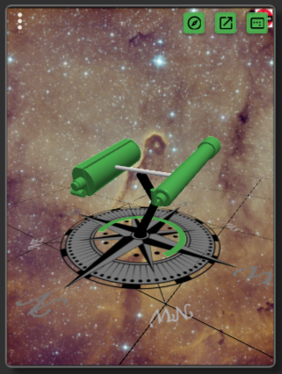
Polar Equatorial – The Polar equatorial mount, in a dual telescope or fork configuration can allow arbitrary rotation around both the right ascension and declination axis. The right ascension axis is aligned with the celestial pole. Celestial objects are tracked by rotating this axis at the sideral rate.
There is no counterweight for a polar equatorial. mount. Dual telescopes balance each other, and a canted pier means that collisions are avoided. A single telescope is automatically balanced when mounted centrally in a fork which also allows free movement.
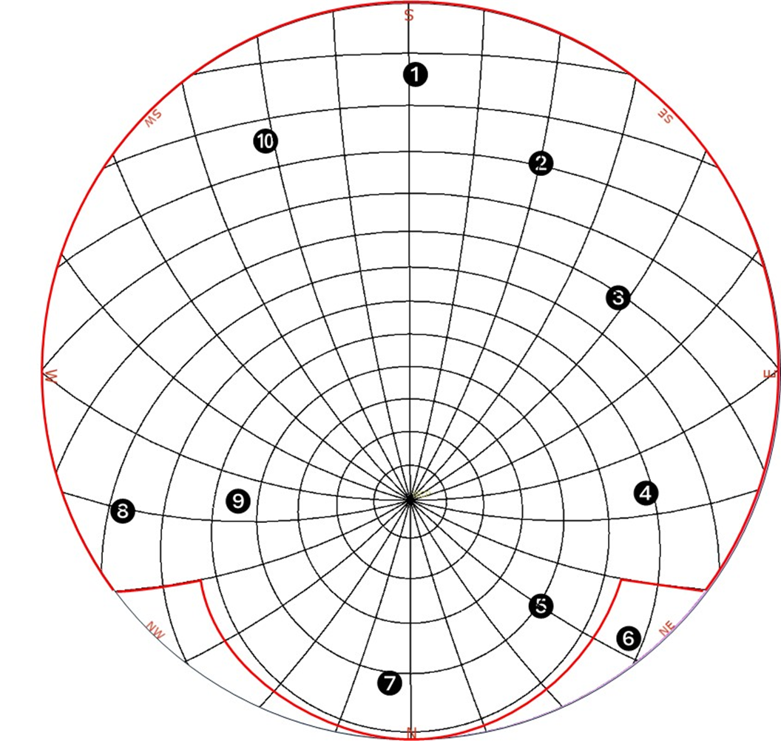
A Polar equatorial mount has two possible orientations for each point on the celestial sphere. Hardware and cable wrap constraints may prevent slewing to both orientations. Hardware limits, in certain cases may make some celestial coordinates unreachable in either orientation. A polar flip swaps between the two orientations, normal and through pole.
The schematic above shows the celestial sphere with the celestial pole in the lower half. Lines of constant right ascension radiate out from the celestial pole and lines of constant declination approximate to circles around the celestial pole. For an example hardware limited polar mount the red line defines the reachable parts of the celestial sphere.
Points 1, 2, 3 and 10 are only reachable using “normal” declination values. Points 4 and 9 are reachable using “normal” and “through pole” declination values. Polar flip will work for points 4 and 9. Points 5, 6 and 8 are only reachable using “through pole” declination values. Point 6 is unreachable.
Altitude Azimuth – The altitude azimuth (AltAz) mount is a simple two-axis mount for supporting and rotating a telescope about two perpendicular axes: one vertical and the other horizontal. Celestial objects can only be tracking by simultaneously rotating both axes.
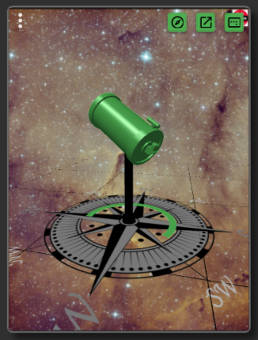
A celestial object’s right ascension and declination map to a unique azimuth and altitude for a given observatory location and time.
An Alt Az mount could move to the object’s azimuth and altitude by rotating clockwise or counterclockwise from the starting position. However, cable wrap constraints may not allow one of the rotation directions.
Most Alt Az mounts allow some azimuth movement in excess of 180 degrees from the zero position, usually North. Thus, there will be a range of azimuth positions around the South that can be reached in two ways.
An Alt Az flip will swap between these positions.

SkyWatcher Scripting

WARNING! – use the API at your own risk. It’s recommended that you do not leave the mount alone while running scripts. Green Swamp is not responsible for any damage resulting from using the API interface.
Running scripts requires that GSS be running and connected to the mount. You can start GSS on its own or by using other external programs that will load the GSS ASCOM driver such as CDC or SGP. Unless you’re experienced with how GSS separates ASCOM commands from the API It’s recommended that GSS be running on its own so no other external sources can interfere or interact with running scripts.
GSS exposes a number of class members available to external programs and scripting languages. There are PowerShell example scripts located in the GSS Program files scripting directory. Find the installation section of this manual for directory locations.
The example scripts we’re created using the Windows 10 PowerShell ISE. To run PowerShell, type in the Windows search box “PowerShell ISE” and run either the 64 bit or X86 versions. You may run into problems executing scripts because of Windows security settings. There are a number of ways to correct this and you should search google for Microsoft’s recommended approach. One way is to allow the current logged in user the ability to run script. The following command can be run within PowerShell by placing it on the first line and clicking execute or the run button.
Set-ExecutionPolicy -Scope CurrentUser -ExecutionPolicy Bypass -Force;

SkyWatcher API

This list contains the definition for the available API commands.
public interface ISky
{
/// <summary>
/// Tells GSS not to process any AsCoM moment commands for external programs using the AsCoM driver.
/// </summary>
/// <returns>bool</returns>
- bool AscomOn { get; set; }
/// <summary>
/// Starts the AutoHome slew to home sensors
/// </summary>
/// <param name="degreelimit"></param>
/// <param name="offsetdec"></param>
- void AutoHomeStart(int degreelimit = 100, int offsetdec = 0);
/// <summary>
/// Stops Auto home from completing
/// </summary>
- void AutoHomeStop();
/// <summary>
/// Move axis number of micro steps, not marked as slewing
/// </summary>
/// <param name="axis">>axis number 1 or 2</param>
/// <param name="steps">number of micro steps</param>
/// <returns>nothing</returns>
- void AxisMoveSteps(int axis, long steps);
/// <summary>
/// Send a pulse command
/// </summary>
/// <param name="axis">Axis 1 or 2</param>
/// <param name="guideRate">GuideRate degrees, 15.041/3600*.5, negative value denotes direction</param>
/// <param name="duration">length of pulse in milliseconds, always positive numbers</param>
/// <param name="backlashSteps">Positive micro steps added for backlash</param>
/// <returns>nothing</returns>
- void AxisPulse(int axis, double guideRate, int duration, int backlashSteps = 0);
/// <summary>
/// Goto position in degrees
/// </summary>
/// <param name="axis">axis number 1 or 2</param>
/// <param name="targetPosition">position in degrees</param>
/// <returns>nothing</returns>
- void AxisGoToTarget(int axis, double targetPosition);
/// <summary>
/// Slew axis based on a rate in degrees. Use this for small movements
/// like pulse guiding, rate changes, guiding changes, not go tos
/// </summary>
/// <param name="axis">axis number 1 or 2</param>
/// <param name="rate">rate/sec in degrees</param>
/// <returns>nothing</returns>
- void AxisSlew(int axis, double rate);
/// <summary>
/// K Slows to a stop movement of an Axis
/// </summary>
/// <param name="axis">axis number 1 or 2</param>
- void AxisStop(int axis);
/// <summary>
/// L Abruptly stops movement of an Axis
/// </summary>
/// <param name="axis">axis number 1 or 2</param>
/// <returns>nothing</returns>
- void AxisStopInstant(int axis);
/// <summary>
/// q Axes slews must start independently
/// </summary>
- bool CanAxisSlewsIndependent { get; }
/// <summary>
/// q Does mount support AZ/EQ mode
/// </summary>
- bool CanAzEq { get; }
/// <summary>
/// q Does mount support dual encoders
/// </summary>
- bool CanDualEncoders { get; }
/// <summary>
/// q Does mount support half current tracking
/// </summary>
- bool CanHalfTrack { get; }
/// <summary>
/// q Does mount support home sensors
/// </summary>
- bool CanHomeSensors { get; }
/// <summary>
/// q Does mount support a polar LED
/// </summary>
- bool CanPolarLed { get; }
/// <summary>
/// q Does mount support PPec
/// </summary>
- bool CanPPec { get; }
/// <summary>
/// q Does mount support WiFi
/// </summary>
- bool CanWifi { get; }
/// <summary>
/// Bypass for mount commands
/// </summary>
/// <param name="axis">1 or 2</param>
/// <param name="cmd">The command char set</param>
/// <param name="cmdData">The data need to send</param>
/// <param name="ignoreWarnings">ignore serial response issues?</param>
/// <returns>mount data, null for IsNullOrEmpty</returns>
/// <example>CmdToMount(1,"X","0003","true")</example>
- string CmdToMount(int axis, string cmd, string cmdData, string ignoreWarnings);
/// <summary>
/// Sets the amount of steps added to Dec for reverse backlash pulse
/// </summary>
- int DecBacklash { get; set; }
/// <summary>
/// Gets the number of steps from the angle in rad
/// </summary>
/// <param name="axis"></param>
/// <param name="angleInRad"></param>
/// <returns>Steps in rad</returns>
- long GetAngleToStep(int axis, double angleInRad);
/// <summary>
/// e Gets versions of axis in long format
/// </summary>
/// <param name="axis"></param>
/// <returns>long axis version</returns>
- long GetAxisVersion(int axis);
/// <summary>
/// e Gets version of axis in string readable format
/// </summary>
/// <param name="axis"></param>
/// <returns>string axis version as string</returns>
- string GetAxisStringVersion(int axis);
/// <summary>
/// j Gets current axis position in degrees
/// </summary>
/// <param name="axis">axis number 1 or 2</param>
/// <returns>Get Current Axis position as double</returns>
- double GetAxisPosition(int axis);
/// <summary>
/// j Gets axis position counter
/// </summary>
/// <param name="axis">axis number 1 or 2</param>
/// <param name="raw">false to subtract 0x00800000</param>
/// <returns>Cardinal encoder count as long</returns>
- long GetAxisPositionCounter(int axis, bool raw = false);
/// <summary>
/// d Gets Axis Current Encoder count
/// </summary>
/// <param name="axis">axis number 1 or 2</param>
/// <returns>count as double</returns>
- double GetEncoderCount(int axis);
/// <summary>
/// Get :j data only not dependent on the advanced set
/// </summary>
/// <param name="axis">axis number 1 or 2</param>
/// <param name="raw">false to subtract 0x00800000</param>
/// <returns>Cardinal encoder count as long</returns>
- double Get_j(int axis, bool raw);
/// <summary>
/// Multiply the value of radians/second by this factor to get a 32-bit integer for the set speed used by the motor board.
/// </summary>
/// <param name="axis">axis number 1 or 2</param>
/// <returns>factor used to get the speed</returns>
- double GetFactorRadRateToInt(int axis);
/// <summary>
/// Inquire motor high speed ratio
/// </summary>
/// <param name="axis">axis number 1 or 2</param>
/// <returns>Ratio used to determine high speed</returns>
- long GetHighSpeedRatio(int axis);
/// <summary>
/// q Get Home position
/// </summary>
/// <param name="axis">axis number 1 or 2</param>
- long GetHomePosition(int axis);
/// <summary>
/// h Get Current "goto" target
/// </summary>
/// <param name="axis">axis number 1 or 2</param>
- double GetLastGoToTarget(int axis);
/// <summary>
/// i Get Current "slew" speed
/// </summary>
/// <param name="axis">axis number 1 or 2</param>
- long GetLastSlewSpeed(int axis);
/// <summary>
/// Margin used to move from high speed to low speed
/// </summary>
/// <param name="axis">axis number 1 or 2</param>
/// <returns></returns>
- long GetLowSpeedGotoMargin(int axis);
/// <summary>
/// e Gets the complete version string
/// </summary>
/// <returns></returns>
- string GetMotorCardVersion(int axis);
/// <summary>
/// s Inquire PEC Period ":s(*1)", where *1: '1'= CH1, '2'= CH2, '3'= Both.
/// </summary>
/// <param name="axis">axis number 1 or 2</param>
- double GetPecPeriod(int axis);
/// <summary>
/// Capture axes position and timestamp. 8 hex for ra, 8 hex for dec, 16 hex in microseconds
/// </summary>
/// <param name="raw"></param>
/// <returns></returns>
- string GetPositionsAndTime(bool raw);
/// <summary>
/// c Micro steps from target where the ramp down process begins
/// </summary>
/// <param name="axis">axis number 1 or 2</param>
- double GetRampDownRange(int axis);
/// <summary>
/// D Sidereal rate in axis speed
/// </summary>
/// <returns></returns>
/// <param name="axis">axis number 1 or 2</param>
- long GetSiderealRate(int axis);
/// <summary>
/// Gets the angle in rad from amount of steps
/// </summary>
/// <param name="axis"></param>
/// <param name="steps"></param>
/// <returns></returns>
- double GetStepToAngle(int axis, long steps);
/// <summary>
/// a Steps per revolution
/// </summary>
/// <param name="axis">axis number 1 or 2</param>
/// <returns>Step Count</returns>
- long GetStepsPerRevolution(int axis);
/// <summary>
/// b Frequency of stepping timer
/// </summary>
/// <param name="axis">axis number 1 or 2</param>
/// <returns>Frequency of stepping timer</returns>
- long GetStepTimeFreq(int axis);
/// <summary>
/// The current Declination guide rate
/// </summary>
- double GuideRateDeclination { get; set; }
/// <summary>
/// The current Right Ascension guide rate
/// </summary>
- double GuideRateRightAscension { get; set; }
/// <summary>
/// F Initialize both Axes
/// </summary>
- void InitializeAxes();
/// <summary>
/// Is the auto home process running
/// </summary>
- bool IsAutoHomeRunning { get; }
/// <summary>
/// Is mount in a connected serial state
/// </summary>
- bool IsConnected { get; }
/// <summary>
/// Starts or Stops mount and connection
/// </summary>
- bool IsMountRunning { get; set; }
/// <summary>
/// Is mount parked
/// </summary>
- bool IsParked { get; }
/// <summary>
/// q Is the mount collecting PPec data
/// </summary>
- bool IsPPecInTrainingOn { get; }
/// <summary>
/// q Does the mount have PPec turned on
/// </summary>
- bool IsPPecOn { get; }
/// <summary>
/// j Is axis at full stop
/// </summary>
/// <param name="axis">axis number 1 or 2</param>
/// <returns></returns>
- bool IsFullStop(int axis);
/// <summary>
/// j Is axis in high speed mode
/// </summary>
/// <param name="axis">axis number 1 or 2</param>
/// <returns></returns>
- bool IsHighSpeed(int axis);
/// <summary>
/// Is mount type set to SkyWatcher
/// </summary>
- bool IsServerSkyWatcher { get; }
/// <summary>
/// f Is axis slewing normal mode
/// </summary>
/// <param name="axis">axis number 1 or 2</param>
/// <returns></returns>
- bool IsSlewing(int axis);
/// <summary>
/// f Is axis slewing in a positive direction
/// </summary>
/// <param name="axis">axis number 1 or 2</param>
/// <returns></returns>
- bool IsSlewingForward(int axis);
/// <summary>
/// f Is axis slewing in goto mode
/// </summary>
/// <param name="axis">axis number 1 or 2</param>
/// <returns></returns>
- bool IsSlewingTo(int axis);
/// <summary>
/// Last known error from the AutoHome Process
/// </summary>
- string LastAutoHomeError { get; }
/// <summary>
/// e Identify type of mount
/// </summary>
- string MountType { get; }
/// <summary>
/// e Identify board version
/// </summary>
- bool MountVersion { get; }
/// <summary>
/// Park mount to the current selected park position
/// </summary>
- void Park();
/// <summary>
/// Get parked selected or Set to an existing park position name
/// </summary>
- string ParkPosition { get; set; }
/// <summary>
/// Turns PPec off during movements and then back on for error correction moves
/// </summary>
/// <param name="on"></param>
- void SkySetAlternatingPPec(bool on);
/// <summary>
/// E Reset the position of an axis
/// </summary>
/// <param name="axis">axis number 1 or 2</param>
/// <param name="position">degrees</param>
- void SetAxisPosition(int axis, double position);
/// <summary>
/// E Reset the position of an axis
/// </summary>
/// <param name="axis">axis number 1 or 2</param>
/// <param name="position">degrees</param>
- void SetAxisPositionCounter(int axis, int position);
/// <summary>
/// M Set the break point increment
/// </summary>
/// <param name="axis">axis number 1 or 2</param>
/// <param name="stepsCount">The steps count.</param>
- void SetBreakPointIncrement(int axis, long stepsCount);
/// <summary>
/// Turns on or off converting a Dec pulse guide into a Dec GoTo
/// </summary>
/// <param name="on"></param>
- void SetDecPulseToGoTo(bool on);
/// <summary>
/// W 4-5 Turn on off encoders
/// </summary>
/// <param name="axis">axis number 1 or 2</param>
/// <param name="on"></param>
- void SetEncoder(int axis, bool on);
/// <summary>
/// W 6 Enable or Disable Full Current Low speed
/// </summary>
/// <param name="axis">axis number 1 or 2</param>
/// <param name="on"></param>
- void SetFullCurrentLowSpeed(int axis, bool on);
/// <summary>
/// H Set the goto target increment in steps
/// </summary>
/// <param name="axis">axis number 1 or 2</param>
/// <param name="stepsCount"></param>
- void SetGotoTargetIncrement(int axis, long stepsCount);
/// <summary>
/// W 8 Reset the home position index
/// </summary>
/// <param name="axis">axis number 1 or 2</param>
- void SetHomePositionIndex(int axis);
/// <summary>
/// J Start motion based on previous settings
/// </summary>
/// <param name="axis">axis number 1 or 2</param>
- void StartMotion(int axis);
/// <summary>
/// G Set a different motion mode
/// </summary>
/// <param name="axis">Axis number 1 or 2</param>
/// <param name="func">'0' high speed GOTO slewing,'1' low speed slewing mode,'2' low speed GOTO mode,'3' High slewing mode</param>
/// <param name="direction">0=forward (CW) right, 1=backward (CCW) left, also based on observatory settings</param>
- void SetMotionMode(int axis, int func, int direction);
/// <summary>
/// W 2-3 Turn on off PPec
/// </summary>
/// <param name="axis">axis number 1 or 2</param>
/// <param name="on"></param>
- void SetPPec(int axis, bool on);
/// <summary>
/// W 0-1 Turn on off PPEC training
/// </summary>
/// <param name="axis">axis number 1 or 2</param>
/// <param name="on"></param>
- void SetPPecTrain(int axis, bool on);
/// <summary>
/// I Set slewing rate, seems to relate to amount of skipped step counts.
/// </summary>
/// <param name="axis">axis number 1 or 2</param>
/// <param name="stepSpeed">StepSpeed = 1 motor step movement, higher counts means slower movements</param>
- void SetStepSpeed(int axis, long stepSpeed);
/// <summary>
/// Set simulator goto rate
/// </summary>
/// <param name="rate">1-20</param>
- void SetSimGotoSpeed(int rate);
/// <summary>
/// S Set absolute goto target
/// </summary>
/// <param name="axis">axis number 1 or 2</param>
/// <param name="position"></param>
- void SetTargetPosition(int axis, double position);
/// <summary>
/// shutdown and close the server
/// </summary>
- void ShutdownServer();
/// <summary>
/// UnPark mount
/// </summary>
- void UnPark();
}

Learn More

Join us on Groups.io at https://groups.io/g/GSS/topics
Videos available at https://vimeo.com/user103775098
Facebook at https://www.facebook.com/groups/517303835383709/

